TOUCHSTONE

POLICY ON PAYING SERVICE USERS AND CARERS FOR SERVICE USER INVOLVEMENT

1. INTRODUCTION

This document is intended to ensure consistency and good practice in the offering of payment of expenses to service users and carers.

This policy is consistent with the “Good Practice Guidance” which has been signed up to by the following Organisations:

- Leeds and York Partnership Foundation NHS Trust
- Leeds Adult Social Care
- NHS Leeds (Primary Care Trust)
- Volition

2. PRINCIPLES

People using mental health services and their carers have expertise from their own experience and a valuable contribution to make to the development and delivery of services. Offering payment, in some circumstances, and expenses, in all cases, is a way of recognising people’s expertise and contribution to mental health services, as well as strengthening service user and carer involvement.

3. INVOLVEMENT AGREEMENTS

All service users/carers who are being paid to undertake ongoing pieces of involvement work for Touchstone should understand their role and any responsibilities they might have. In order to clarify for the organisation and the service user/carer what the purpose of the involvement is, an involvement agreement should be entered into and signed by both parties. appendix 1 is an example involvement agreement that should be used for this purpose and appendix 1.1 is a blank agreement to be completed with service users/carers.

4. PAYMENTS

Payments may only be made for the following activities:

- Attendance at monthly Service User Involvement meetings (News4You) including for chairing and minuting meetings
- Involvement in recruitment, Quality Assurance Framework audits, Policy/Budget Review Groups, Formal Service Review and Compliment and Complaint panels.
- Attendance at Board training events
- Delivering a presentation/training on behalf of Touchstone
- Participation in consultation initiatives for which Touchstone receives funding for that purpose
- Any other activity as agreed with Touchstone service users/carers

Service users/carers will only be eligible for 1 paid activity per week to ensure compliance with benefit rules.

Recipients of payments will be responsible for declaring any monies to the relevant bodies such as the Department for Work and Pensions.

5. INVOLVEMENT RATES

- News4You attendees will be paid £5.00
- All other involvement will be paid at the rate of £15.00 per day or part of a day except recruitment and full day training which is delivered by the service user/ carer which will be paid at £30.00 per day. For the purposes of this policy, a half day is up to 4 hours and a full day is over 4 hours.

6. EXPENSES

All reasonable out of pocket expenses will be reimbursed, where attendance at an activity/meeting is requested by Touchstone. Carers’ costs cannot be met.

Service users/carers will be encouraged to use public transport wherever possible. Payment for taxis should be discussed and agreed in advance with Touchstone staff. A rate of 45 pence per mile will be paid for service users/carers travelling by car. This will cover travel from home to the agreed destination and back again.

All reimbursements must be supported by a valid receipt.

Appendix 2 is an 'at a glance' chart showing involvement fees and expenses entitlement.

Please note: - Reimbursed travel expenses are viewed as “income” by the Department for Work & Pensions and should be declared. Pre-booked taxis that are paid for by Touchstone are not classed as income in this way.

7. RESPONSIBILITIES OF SERVICE USERS/CARERS

It is the choice of each individual to accept or waive a payment.

Unless there are exceptional circumstances, a claim for attendance may only be authorised when a service user/carer has attended for at least 50% of the meeting/activity. This does not apply if the meeting is cancelled at short notice or, there are not enough attendees to continue.

It is the responsibility of the individual receiving a payment to inform the relevant agency of any earnings that may affect their benefits or income tax status. For a full understanding of any entitlement or responsibility under Permitted Work rules, see the flow chart at appendix 3.

Wherever possible individuals should provide evidence of actual expenses incurred.

Each individual receiving a payment will sign a receipt form to confirm that they have received the monies owed (see appendix 4).

8. COMMISSIONED INVOLVEMENT

  - In 2010 the law changed allowing Public Authorities (who are required by law
to involve service users and carers) to pay up to £97.50 per week for involvement and expenses without affecting a person’s benefits’ entitlement.

  - Only people in receipt of Incapacity Benefit or Employment Support Allowance are eligible for this higher payment providing they get JobCentre Plus advice prior to starting paid involvement work.

  - Public Authorities can commission other organisations, such as Touchstone,
to undertake this involvement and, in these cases, the rate payable will be up to £97.50 per week, subject to the provisions of the contract, as well as the budget, provided by the Public Authority.

  - Public Authorities that are required by law to involve service users and carers
include:
- local authorities
- NHS Trusts and Health Boards
- University social work and training courses

9. REFERENCES

The following documents were used in the development of this policy:

Department of Health Guidance, Reward and Recognition-the-principles and Practice of service user payment and reimbursement in Health and Social Care 2006
Guidance for Supporting Service Users and Carers in their involvement to Improve Health and Social Care Services Across Leeds

SocialFirms UK 2010 with benefits information provided by Judy Scott Consultancy, Online Permitted Work Guide, reproduced with permission.

Social Care Institute for Excellence ‘At a Glance 50: Reimbursements and payments for service user involvement’ October 2011.

Service users were involved in the development of this policy.

Agreed: May 2012
Appendix 1
An example of an Involvement Agreement

Name of Project/Activity/Meeting

Purpose/Aims of project/activity/meeting

The aim of the project is to…..

Timescale and commitment of the project/activity/meeting
For instance:

The (activity) will take place over 6 months

The (activity) is ongoing

Where project/activity/meeting will be held

Role of participant and experience/skills required
For instance:

To contribute your views and ideas, based on your experience, to meet the aims of (the activity)

To represent the views and ideas of service users to meet the aims of (the activity)

Responsibilities of participant
For instance:

To participate in regular meetings (state regularity)

To let (relevant member of staff) know if you are unable to attend a meeting

To tell (relevant member of staff) if you have any issues or concerns or if there is anything you don’t understand

Responsibilities of member of staff leading the project/activity/meeting
For instance:

To discuss appropriate support and make sure it is provided (eg pre-meetings, de-briefing etc.)

To make sure relevant information (eg minutes of meetings, are sent to the participant in plenty of time

To discuss training needs and make sure they are met wherever possible

To offer an involvement fee and out-of-pocket expenses at the end of each (meeting)

To let the participant carer know if a (meeting) is cancelled

To ensure that staff avoid jargon and explain it where has to be used.

Contact details of member of staff

Signed: ………………………………………………………….. Service User/Carer

Date: ………………………………………………………….

Signed: …………………………………………………………. Staff Member

Date: ………………………………………………………….
Appendix 1.1
Touchstone Involvement Agreement

Name of Project/Activity/Meeting

Purpose/Aims of project/activity/meeting

Timescale and commitment of the project/activity/meeting

Where project/activity/meeting will be held

Role of participant and experience/skills required

Responsibilities of participant

Responsibilities of member of staff leading the project/activity/meeting

Contact details of member of staff

Signed: ………………………………………………………….. Service User/Carer

Date: ………………………………………………………….

Signed: …………………………………………………………. Staff Member

Date: ………………………………………………………….

Appendix 2 - 'At a glance' payment chart

TYPE OF ACTIVITY | Examples | £5 fee | £15 fee | £30 fee | Travel expenses | Other out of pocket expenses considered
 |  | FEES CAN ONLY BE PAID ONCE PER WEEK, REGARDLESS OF THE NUMBER OF ACTIVITIES YOU ARE INVOLVED IN. EXPENSES WILL BE PAID FOR ALL ACTIVITIES.
RECRUITMENT | -Short listing candidates (full day)  -Being on an interview panel (full day) |  |  | 
BIDDING PROCESS | - Contributing to tendering or bid-writing  - Presenting a bid with Touchstone staff
SERVICE USER INVOLVEMENT MEETINGS | - News for You meeting attendance  - Service user forums  - Chairing/ Minutes Meetings
BEING A TRAINER | - Providing training to Touchstone staff as part of our in-house training programme.  -Providing training to other organisations where this has been organised by Touchstone. |  |  | May be full day in some cases
BEING A RESEARCHER | - Working with Touchstone to carry out community research
BOARD OF TRUSTEE MEETINGS | - Being a board member
 | - Being an advisor at Board meetings – 1st 3 meetings only.
 | - Attending sub-committees of the Board of Trustees
BEING A CONSULTANT | - Working with a Touchstone member of staff to do a specific piece of work  - Helping to lead a particular event  -Volunteering at a particular event
CHECKING TOUCHSTONE IS DOING ITS JOB PROPERLY | - Being on a Quality Standards audit team.  - Attending a SU Compliments and Complaints panel
NEWSLETTERS | - Pulling together a newsletter for service users
GIVING FEEDBACK | - completing a service user questionnaire  - speaking to a worker  - writing a compliment or complaint
SERVICE USER CONSULTANT ROLE | - A specific role at Touchstone with a job description. | Weekly payment of £20 covers all fees and expenses

Appendix 3
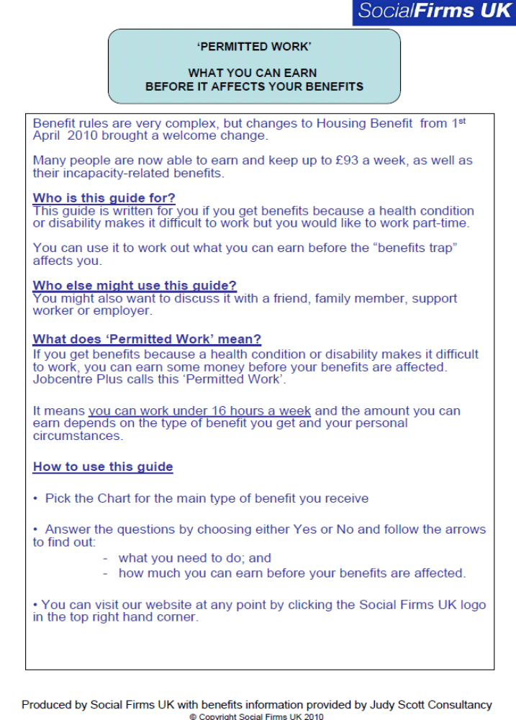

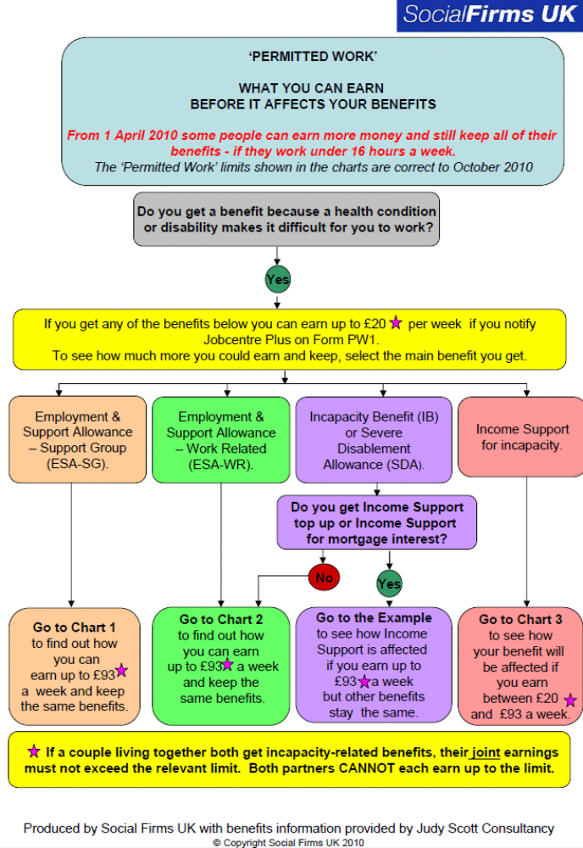
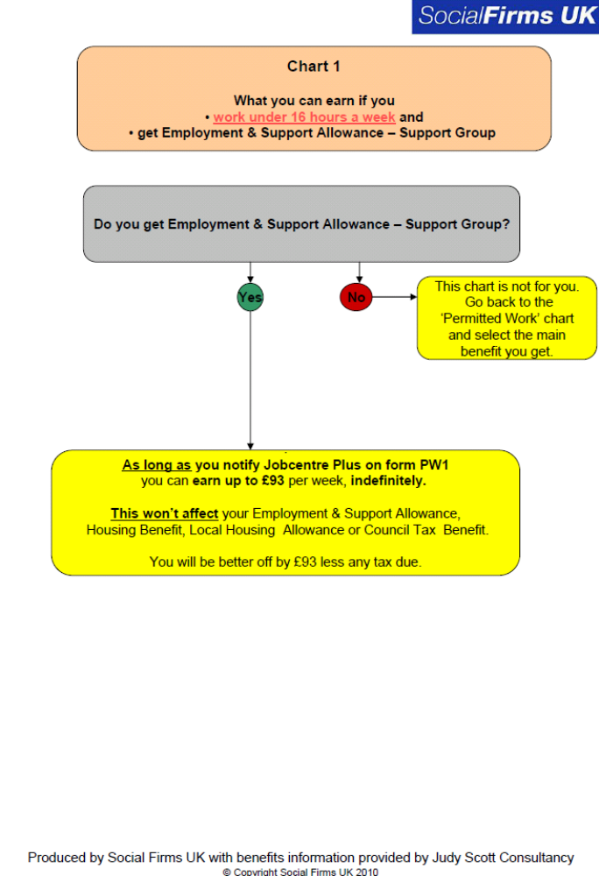

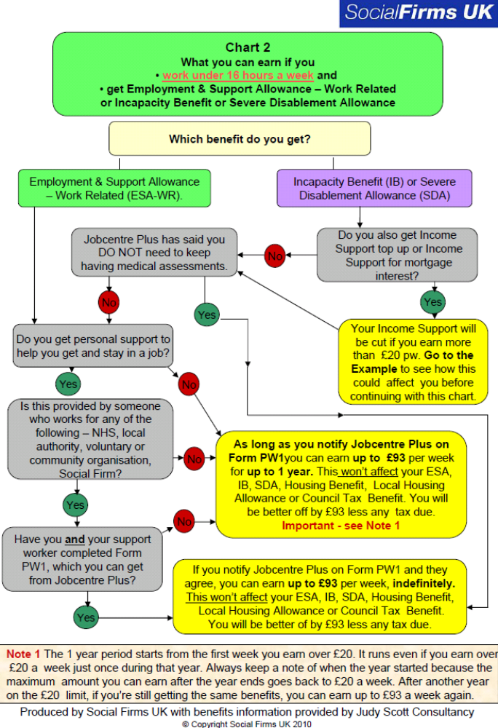
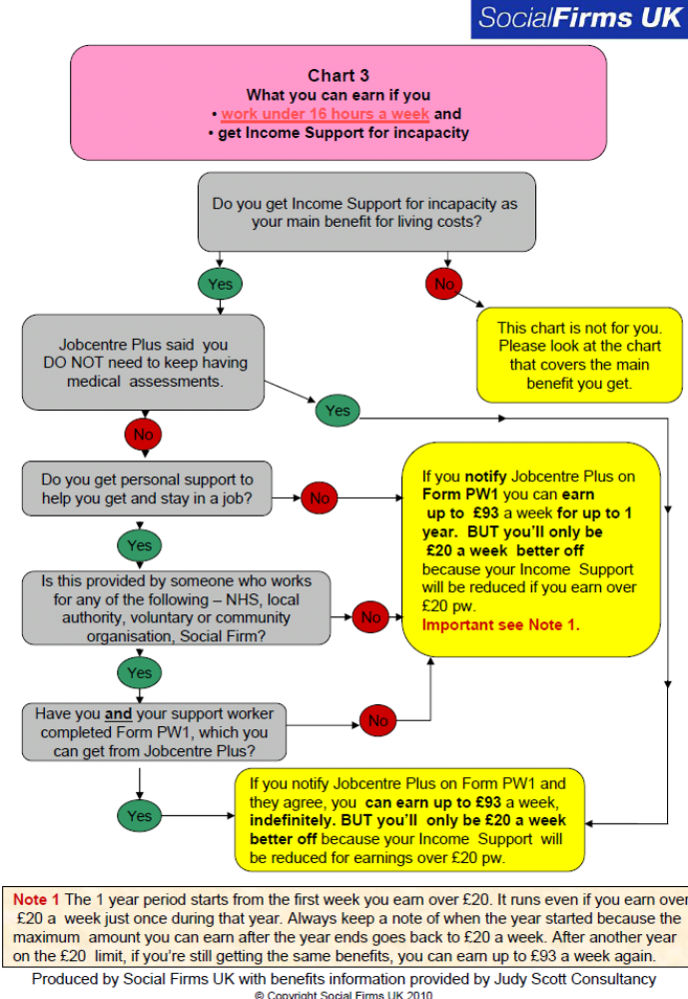
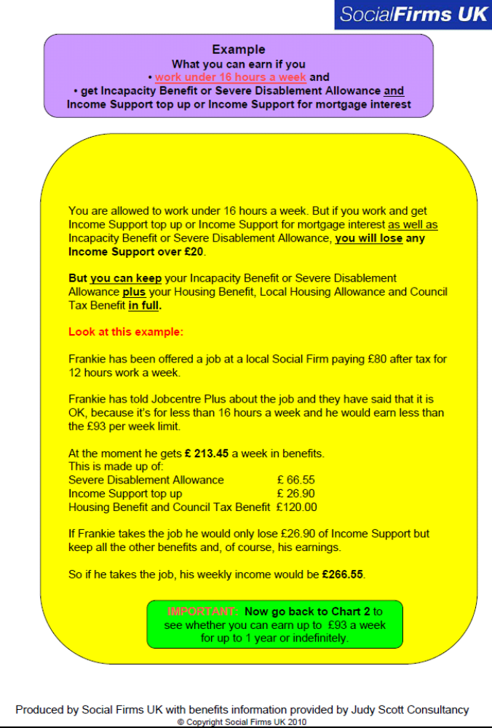
Appendix 4


This payment is a gross amount. I am responsible for paying income tax, if due and informing any relevant agencies.
I ……………………………………… acknowledge receipt of £……..………. from

Touchstone

for expenses/payment for involvement in the following activity:

…………………………………………………………………………………………….

Signed ……………………………………………………… Service User/Carer

Date ………………………………………………………….

-----------------------------------------------------------------------------------------------------------

This payment is a gross amount. I am responsible for paying income tax, if due and informing any relevant agencies.
I ……………………………………… acknowledge receipt of £……..………. from

Touchstone

for expenses/payment for involvement in the following activity:

…………………………………………………………………………………………….

Signed ……………………………………………………… Service User/Carer

Date ………………………………………………………….

