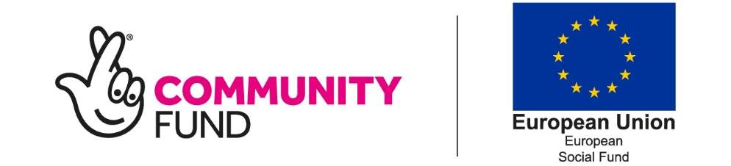
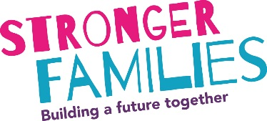
Referral and Initial Consent Form
Participant details and consent
Name: |  |  |  |  |  |  | Gender:
DOB: |  |  |  |  |  |  | Telephone:
Address: |  |  |  |  |  |  | Email:
Postcode: |  |  |  |  |  |  | Date:
☐ | I confirm that my name and contact details can be shared with Stronger Families Programme partners in association with Building Better Opportunities projects who will contact me to discuss the programme. To assess my suitability for Stronger Families I consent to my information being shared with the Local Authority. Your information will be kept secure.

Eligibility and support needed:
We need to check that the person you are referring is eligible to join this programme. The programme is open to individuals, with a dependent child, who are not in paid work and are eligible to work in the UK.

Please tick the following that apply:
☐ | Participants age 18+ (or 17+ but not in education) and with at least one dependent child
☐ | Is economically inactive (i.e. they are not in paid employment or self-employment and are not available for or not seeking work.)
☐ | Is unemployed (i.e. they are entirely without work, but are available for and actively seeking work. They will usually be registered unemployed and be in receipt of unemployment benefits.)
☐ | To my knowledge this participant has the right to work in the UK
Please specify which benefits are being claimed (if any/known):
Number of dependent children:

The participant needs support for themselves or their family with one of the following:
☐ | Low school attendance | ☐ | Anti-Social behaviour
☐ | Domestic violence | ☐ | Financial exclusion
☐ | Physical health | ☐ | Housing
☐ | Social Emotional Mental Health | ☐ | Other (Please specify):
Is an interpreter needed? If yes please specify language:

Referrer Information
Referrer Name:
Company/Service:
Email:
Phone:
Please specify here if there’s any other important information.
☐ | I can confirm in accordance with GDPR and Data Protection Legislation that I have lawful basis to share this personal data.
Please send this referral to one of the below emails. Please note that if the participant lives in Leeds the referrals will need to go to Barca-Leeds and if they live in Bradford the referral will need to go to Barnardos.
Leeds |  |  |  |  |  |  | Bradford
Please password protect documents sent via email/or send via secure email.  Strongerfamilies@barca-leeds.org or Stronger.families@wyfi.cjsm.net (can only be sent to this address via another secure account) |  |  |  |  |  |  | Please password protect documents sent via email/or send via secure email. StrongerFamiliesBradford@barnardos.org.uk
We are happy to take referrals over the phone: 0113 386 9900 |  |  |  |  |  |  | We are happy to take referrals over the phone: 01274 513 300

