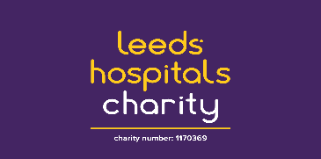

MyPlan -Touchstone Perinatal Service Referral Form

The My Plan Perinatal Service is funded with a grant from NHS Charities Together, the national charity partner of the NHS. We help women in Bradford who are suffering with perinatal mental health issues as a result of a recent pregnancy or as a result of existing problems that might get worse with an upcoming pregnancy. We provide one to one support to women living in Bradford experiencing low to moderate perinatal mental health issues, focusing on improving wellbeing and mental health.

Telephone referrals can be made to Jayne 07919967116 or Lisa 07435923166
Email myplan@touchstonesupport.org.uk

REFERRERS DETAILS
Name
Address/Organisation
Contact phone number
Email address

REFERRAL INFORMATION
Reason for Referral:

Date of Referral
Any known risks? | Yes ☐ | No ☐
 | If YES, please give info/provide copy of risk assessment
What is their preferred language to communicate in?

