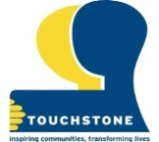
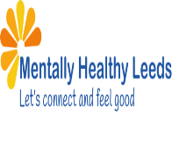

Touchstone and Mentally Healthy Leeds
Anti Stigma Champions present:

Living Library Event to Celebrate World Mental Health Day 2022
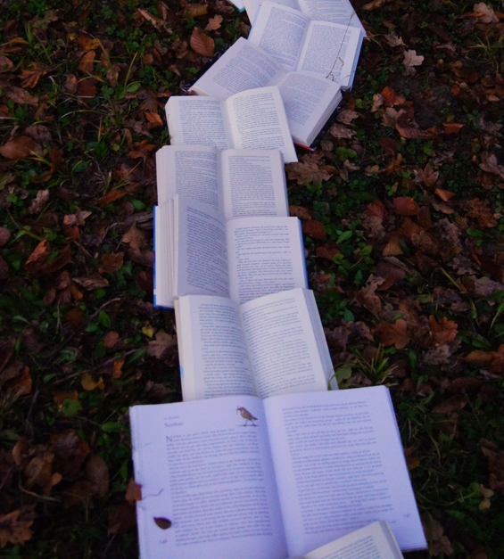

Henry Barran Centre, Amberton Road
Gipton, Leeds, LS8 3JR

Come and hear from a ‘Living Library Book’
about their personal mental health journey
and how they manage their mental wellbeing
in a fun environment

Monday 10th October 2022 from 10am until 4pm
Free Tombola and refreshments available
Please contact Steph Francis for more information on 07823 448432 or email stephanief@touchstonesupport.org.uk

