Touchstone’s

Winter

Wellbeing

Booklet

Rotherham

Contents

Mental Health Support 3

Support with Violence and Abuse 4

Other Key Support 6

Warm Spaces 7

Other Info on Keeping Warm 8

Getting Food this Winter 9

Christmas Dinner on a Budget 10

Mental Health Support

If you are struggling this Winter, you are not alone. There are lots of people who can help – take a look below.

NHS
- Call 999 in an emergency
- Call 111 – For help with your mental and physical health when you’re not sure what to do.

Samaritans
- Here to listen and talk, no matter what you’re going through
- Call 116 123 (open 24/7)

24 Hour Mental Health Helpline
- If you’re in crisis outside of office hours, please phone the RDaSH team for support and signposting to the next steps for care
- Call: 0800 652 9571 (open 24/7)
- If you are hard of hearing, Deaf, or unable to use the telephone line to call, please text: 07974 603 610
Rotherham Safe Space
- Offers one-to-one support every night from 6pm-midnight for anyone 18+ in crisis.
- Call 07760 173504 (Fri-Sun) on the night you want to visit
- For more on professional referrals, please visit: https://TouchstoneSupport.org.uk/intensive-community-support/rotherham-safe-space/

Support with Violence and Abuse

The Winter holidays can be times where abuse and violence get worse. If you have experiences of violence and abuse, there are lots of places that can help.

National Domestic Violence Helpline (Refuge)
- Call 0808 2000 247 (open 24/7).
- Online Live Chat: www.NationalDAHelpline.org.uk/en/Chat-to-us-online (open Mon-Fri, 3-10pm)
- Web Form: www.NationalDAHelpline.org.uk/en/Contact-us

Rape Crisis (England and Wales)
- Here to talk for all people aged 16+ who have experienced any type of sexual violence
- Call 0808 802 9999 (open 24/7)
- Chat to them online: https://RapeCrisis.org.uk/get-help/want-to-talk/ (open 8am-midday every day, may change in holidays)

Rotherham Rise
- Support and advice around domestic violence and abuse
- Call 0330 2020 571 (open Mon-Fri 9am-5pm, may change in holidays)
- Email help@RotherhamRise.org.uk
- Online Support Form: https://RotherhamRise.org.uk/help/

GALOP
- Support for LGBTQIA+ people with experiences of domestic violence and abuse
- Phone 0800 9995428 (open Mon-Fri 10am-5pm, Wedns and Thurs, 10am-8pm - closed weekends and bank holidays)
- Email help@galop.org.uk
- Web chat: https://galop.org.uk/ (open Wedns-Thurs, 5-8pm)

Men’s Advice Line
- Supporting men with experiences of domestic violence and abuse
- Phone 0800 801 0327 (open Mon-Fri 10am-8pm)
- Email info@MensAdviceLine.org.uk (open Mon-Fri, 9am-8pm)
- Webchat support: https://MensAdviceLine.org.uk/contact-us/ (open Wednes 10-11:30am and 2:30-4pm)
- Closed Bank Holidays in December and January

National Male Survivor Helpline
- Support for men and boys in England and Wales affected by sexual violence and abuse
- Call 0808 800 5005 (Mon-Fri, 9am-8pm, Sat-Sun 10am-2pm)
- Text Support: 07860 065187
- Email: support@safeline.org.uk
- Online chat: https://safeline.org.uk/contact/

Other Key Support

Drug and Alcohol Recovery Service – Change Grow Live
- Provides free confidential advice around drugs and alcohol
- Call: 01709 917649
- Email: rotherham.admin@cgl.org.uk
- Open Mon, Tues, Wedns, Fri, 9-5pm; Thurs 9-7pm; Sat 9-1pm, closed on bank holidays in December and January

Energy Crisis Support Scheme
- Payment of up to £400 to households struggling to meet the costs of their energy bills
- Applicants will have to provide info about their current financial situation
- For more information, please visit: https://www.rotherham.gov.uk/housing-grants-finance/energy-crisis-support-scheme

Housing and Homelessness Support
- Support and advice around homelessness and housing
- Call 01709 336009, Mon-Fri within office hours.
- If you need help outside of office hours call 07748 143170
- Alternatively, you can fill in their online form here: https://www.rotherham.gov.uk/xfp/form/263

Warm Spaces

During the Cost of Living crisis, there are lots of free spaces you can go to keep warm in Kirklees. Find the map here for more info and opening days/ hours: https://www.rotherham.gov.uk/community-living/warm-welcome-spaces

- Riverside Library and Neighbourhood Hub
- Aston Library
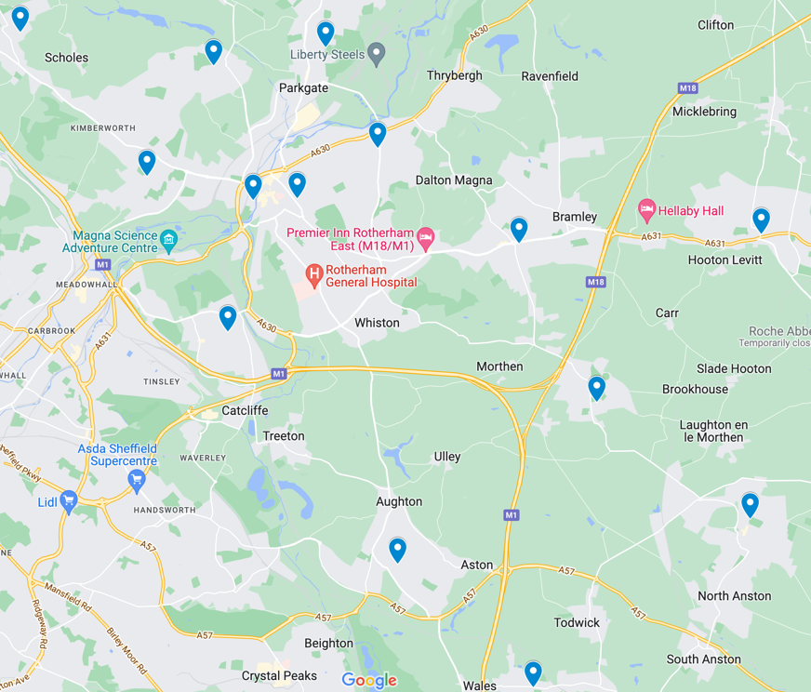
- Brinsworth Library
- Dinnington Library
- Greasbrough Library
- Kiveton Library
- Maltby Library
- Mowbray Gardens Library
- Rawmarsh Library
- Swinton LIbrary
- Wath Library
- Wickersley Library
- Thurcroft Library
- Thorpe Hesley Library
- Kimberworth library
- Archive Search Room At Clifton Park Museum
- Walker Kitchen at Clifton Park Museum

Other Info on Keeping Warm

Government Payments to Help Heat your Home
- Winter Fuel Payments - money towards heating bills for those born before 26 September 1956. If you're eligible, you'll usually be paid automatically.
- Cold Weather Payments - £25 payment if the average temperature in your area is below 0 for 7 days. Open to people on certain benefits or mortgage support.
- Warm Home Discounts - £150 off your electricity bill for some people with different benefits.
To find out more, please visit: www.gov.uk/winter-fuel-payment

People sleeping rough in Winter
- If you want to self-refer for support or are worried about someone sleeping rough at any point in the year, you can report it to your local authority/outreach team via: https://www.StreetLink.org.uk/ or 0300 500 0914
- Rotherham provide emergency accommodation for anyone sleeping rough during sub-zero temperatures
- People sleeping rough can access this service by calling Homelessness Team 01709 336009 (8.30-5pm) or 07748 143170 outside of these hours.
- Members of the public can also use these numbers if they are concerned about someone sleeping rough. In an emergency call 999

Getting Food this Winter

Food banks and other places can support with food and necessities this Winter. Below is some info on where to get support with food in Rotherham.

Foodbanks in Rotherham
- Rotherham Foodbank operate a collection service on Tuesday and Thursday 10am-2pm, for clients with a voucher code.
- Different food banks have different opening times over Winter - it's good to get in touch early and find out info for getting food in time for Christmas
- To get a referral contact a local support agency such as Citizens' Advice:
  - Call Citizens Advice Rotherham on 0808 278 7911
  - Or 01709 515680 to book a video advice callback
You can also get affordable food from the Social Supermarket at Rotherham Minster: https://RotherhamMinster.co.uk/social-supermarket. To get in touch email SocialSupermarket@RotherhamMinster.co.uk or Call 07419 200405.

Christmas Dinner on a Budget

If you want to cook Christmas dinner at home on a budget, here is a handy shopping list to look through:

Christmas Dinner for 4
- Lidl Braemoor Turkey Breast Joints with pork, onion and safe stuffing topped with bacon (frozen) - £5.29
- Lidl Birchwood Pigs in Blankets (12 pack) - £2.29
- Tesco Baking Potatoes (4 pack) - 57p
- Morrisons Prepared Carrots and Broccoli - £1.49
- Morrisons Parsnips - 69p
- Sprouts - 99p
- Tesco Yorkshire Puddings (12 pack) - £1.30
- Morrisons Cranberry Sauce - 59p
- Morrisons Bisto Turkey Gravy Granules - £1.99
Total: £15.20 (Per Person - Serves 4 - £3.80)

Fancy Festive Recipes on a Budget from Bootstrap Cook, Jack Munroe
- Sprout Scones - CookingOnABootstrap.com/2016/12/31/sprout-scones-15p-v/
- Leftover Turkey Curry - CookingOnABootstrap.com/2017/12/26/leftover-turkey-curry-34p/
Please note recipes will be more expensive than Jack lists as some of these price estimates were from a while ago but they will still be relatively budget-friendly

