East Leeds Health for All- Weekly Activities Program
MONDAY
Leeds Hong Kong Women’s Group
10:00am- 1:00PM
Venue: 41-47 Cromwell Mount LS9 7ST
Women only. Free refreshments and activities.
Come along and join Sarah
Warm Space/ Lincoln Green Support Drop-in
12:45PM – 3:00PM
41-47 Cromwell Mount, Lincoln Green
Support with food, utilities; benefits applications; debt management; form filling; housing bids. Information/referrals to other services.
Men and women welcome

WEDNESDAY
Badminton Session
11:00AM – 1:00PM
Men and women welcome
Venue: Fearnville Leisure Centre
To register please contactSarah on P:07824481269
E: sarahs@touchstonesupport.org.uk

THURSDAY
Free Swim Session
11:15AM – 12:45PM
Venue: Scotthall Leisure Centre
Men and women welcome
To register please contact Sarah on P:07824481269
E: sarahs@touchstonesupport.org.uk

 | FRIDAY
Sewing Group
11:00AM – 12:15PM
Venue: Touchstone 41-47 Cromwell Mount
To register please contact
Sarah on P:07824481269
E: sarahs@touchstonesupport.org.uk

SATURDAY
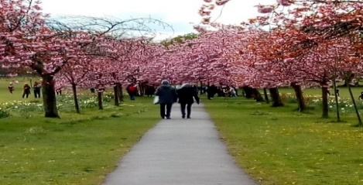 | Free Walking Group  Meeting point at Leeds Central Bus Station Stand 10  Join Sarah at 10:15am with FREE transport.  To register please contact Sarah on P:07824481269  E : sarahs@touchstonesupport.org.uk
For information on any of the groups or activities on this poster please contact
P: 0113 248 4880
E: cmadmin@touchstonesupport.org.uk

