

The Cost of Living Crisis:

How has the Cost of Living Crisis affected the mental health of people on low incomes, and what forms of support have been effective?



By Quenby Harley

Community Health Development Analyst – Data & Intelligence

Mentally Healthy Leeds

June 2023

Table of Contents

Title Page 1

Contents 2

1) Executive Summary 3

2) Introduction 4

3) Background 5

4) Methodology 7

5) Demographics 10

6) Survey Responses 15

7) Limitations 20

8) Recommendations 22

9) Conclusion 24

10) Further Reading 25

11) Appendices 26

1. Executive Summary

This research looks at the effects of the ‘Cost of Living’ crisis on the mental health of people in Leeds, as well as trying to understand what forms of support were effective during this period. The aim was to prioritise the experiences of people on low incomes, as a group particularly vulnerable to this crisis. Data was collected using a survey carried out over 6 weeks in early 2023. We combined quantitative and qualitative methods to identify common themes. The 182 responses to our questionnaire suggest that this is a topic which hit close to home for a lot of people.

The responses paint a clear picture of the ways in which many people are struggling during the crisis, with most participants being very worried about it. Many have had to heavily cut back on food and heating to make ends meet, to the detriment of their health. This has had a significant impact on the mental health of respondents with stress (57%), difficulty sleeping (33%), and the worsening of existing mental health conditions (25%) being the most common responses.

The practical support offered during the crisis was very helpful to those who accessed it. Food banks and similar forms of food provision helped with food costs, while the Warm Spaces scheme provided a social lifeline as well as a chance to escape the cold. However, 53% of our participants hadn’t accessed support despite struggling during the crisis. Stigma and a lack of knowledge about support stopped many from reaching out for help even in some of the most desperate cases.

The responses supported the evidence from background reading suggesting that the crisis has hit those on the lowest incomes hardest. Participants with a household income below £10,000 per year tended to be more worried by the crisis, suffered more extreme effects from the increased cost of living, and their mental health was subsequently more heavily affected as well.

This research was focussed on the winter, and heating costs certainly played a significant role in the crisis. However, it would be short-sighted to assume that these problems disappeared once it got warmer. Some participants spoke of a feeling of hopelessness as they looked ahead, and until the underlying issues which created the crisis are resolved it is hard to say that they are wrong.

To support people through this crisis we recommend the continuation of practical support through food provision and the Warm Spaces program. This should be combined with promotion and outreach aimed at increasing awareness of the support available and fighting the stigma which still surrounds poverty.

1. Introduction

Working with our commissioners and the support of extended professional networks, Mentally Healthy Leeds (MHL) carried out research into the effect of the ‘Cost of Living’ Crisis on people in Leeds. For the purpose of this research we refer to the ‘Cost of Living’ crisis as a period when prices for essential everyday items (such as food, fuel, and housing) are going up significantly faster than peoples incomes. This disproportionately affects poorer households. We look at what this means in greater detail in the Background section.

The underlying question we tried to answer through this research was "How is the cost of living crisis affecting the mental health of those most in need and what kind of support would be effective in mitigating this?" Through conversations with commissioners and within Touchstone, we decided to capture the effectiveness of interventions and any potential gaps in service provision,” as well as tracking the impact of the crisis on people’s mental health.

National data and research indicates people on low incomes are most heavily affected by the ‘Cost of Living’ crisis. Because of this we were keen to engage with people on low incomes, drawing on MHL’s experience working with the 10% most deprived Lower Level Super Output Areas (LSOAs) and professional networks to target our promotion towards this demographic group.

Survey Data was collected between 18th January and 3rd March 2023. Despite the relatively short timeframe (discussed in greater depth in the limitations section) we had a strong response, with 182 responses divided evenly between online survey results and paper copies of the survey. The quantity of responses collected allows for robust data analysis and enables us to look at how people’s experiences of the crisis vary between different income brackets.

1. Background

Since October 2021 regular pay (excluding bonuses) has decreased in real terms in Great Britain. Between April 2022 and January 2023, regular pay has shrunk by 2.3-3.5% compared to the year before according to the ONS (2023). As we can see in Chart 1 below this has been driven by high inflation across the UK, with pay and benefits increases not keeping up with rising costs of living. Because of this crisis most people have had to make some cutbacks in their spending, with those already struggling to make ends meet faced with very hard choices. We have seen strong evidence supporting this through the survey results, covered in detail in the Survey Responses section.

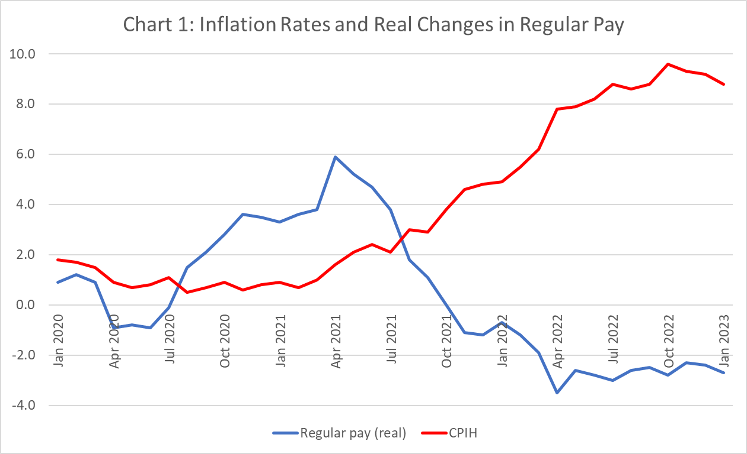

1Real average weekly earnings single-month annual growth rates in Great Britain, seasonally adjusted, and Consumer Prices Index including owner occupiers’ housing costs (CPIH) annual rate, January 2020 to January 2023

A compelling narrative we came across in our background research was “Heat or Eat”, referring to people having to choose between eating food or heating their homes during the winter. This was explored by the Guardian in their series “The heat and eat diaries.” Part of the reason we chose to run this insight report during the winter was the additional financial strain that cold weather places on people due to the need for warm clothing and household heating. Our expectation was that the impact of the crisis would be most pronounced during the winter.

This must be understood in the context of contemporary experiences of poverty. It can be hard to precisely measure exactly how many people live in poverty, as the economic and social circumstances affecting living conditions can vary greatly and there is significant disagreement over where to draw the line. For our purposes it is sufficient to say that a significant proportion of the UK population continue to live in poverty. In Leeds this is a particularly significant challenge as 24% of LSOAs are among the 10% most deprived in the UK.

Our focus on mental health within this report draws on existing research into the links between poverty and mental health. Poverty and social inequality have a significant impact on many aspects of health and access to healthcare, and mental health is certainly included within that. This can be a self-reinforcing pattern, as poverty can be both a cause and an effect of poor mental health. We will not cover this in great depth in this report, but links to research on this topic are included in our further reading section.

Within this research we also tried to capture the effect of interventions put in place this winter to mitigate the effects of the 'Cost of Living’ crisis. These included the warm spaces scheme put in place by Leeds City Council, one-off payments to various demographic groups, the Energy Price Guarantee as well as ongoing support from organisations such as foodbanks.

In Leeds there has been various forms of support put in place, including the Household Support Fund, Winter Pressures Funding and Stay Well This Winter grants. This funding was put in place to fund projects getting essentials like warm clothing and food and fuel vouchers to target populations who were most at risk over the winter. This all ties in to the overarching aim of the Leeds Health and Wellbeing strategy to improve the health of the poorest the fastest.

1. Methodology

We collected demographic information on participants to help understand who we managed to engage during this research, the full demographics question set can be seen in the demographics section, or in the copy of the survey in appendix 1. It is important to note that we included an option to not respond or select “Prefer not to say” in each question. This is included in our survey design in recognition that some participants may not be comfortable disclosing these personal details, and our view is that should not be a basis for exclusion from this research. Our starting point was a standard demographic question set covering age, gender, disability, sexuality, ethnicity, and postcode. To this we added two questions concerning employment status and household income. The decision was made to add these demographic questions as we were interested in how experiences of the 'Cost of Living’ crisis varied between different economic groups.

The question on household income is of only one part of a more complex picture. Capturing a robust view of a household’s financial situation might require questions about household composition, debts or savings, access to benefits, and the social support networks in place. We made an active choice not to ask these more in-depth questions for two reasons. Firstly we were keen for this survey to be relatively short and easy to engage with, the greater detail we could capture through these questions would come at the expense of a straightforward and concise survey. Secondly we were concerned that in-depth questions about financial circumstances could be seen as invasive and discourage engagement with the research.

Drawing on our experience in designing accessible easy read documents from the previous insight report looking into Disability During the Pandemic, we applied these practices to creating an accessible survey. The accessibility considerations included:

* Using plain English with the simplest possible language when writing the survey
* Using a large, easy to read font
* Using examples in questions to help frame the question
* Running the survey through a screen reader to check it reads clearly
* Offering to provide support for anyone who needs help filling in the survey
* Offering to run the research in different formats
* Offering to source translators for participants with limited English skills
* For the rating scale we used emoticons alongside descriptions to provide a visual alternative to the textual descriptions

We offered an incentive for participation in the form of a prize draw for a £50 shopping voucher, randomly selected from the participants who chose to submit their contact details for the prize draw. When collecting data in person we also tried to combine data collection with useful support for participants struggling with the ‘Cost of Living’ Crisis, for example collecting surveys in parts of the Warm Spaces scheme and alongside offers of free food. Where appropriate we also signposted participants to relevant services.

We carried out extensive outreach work to promote this research through professional networks, to relevant groups, and to individuals. This included making use of professional networks, attending groups in person, reaching out to services, using the social media of MHL and Touchstone, and sharing flyers around various locations. We distributed the survey through the email lists of Touchstone, Healthwatch, Mens Health Unlocked, and Forum Central. We also engaged with the Warm Spaces and Financial Inclusion teams at Leeds City Council, Leeds Involving People, Volunteer Action Leeds, SCOPE, and several foodbanks to inform them of our research and ask them to distribute our promotional materials through their networks. We also delivered short presentations advertising the survey at network meetings organised by Forum Central (Mental Health Info and Strategy Meeting on 24th January) and Leeds Involving People (Forum for Racial Equality in Social Care and Health on 26th January.) We also had good engagement from professionals sharing it within their own services.

Our intention was that the survey could be used in a wide range of situations. As well as functioning as an online survey administered through SurveyMonkey the paper version was distributed through existing support and activity groups, at network meetings, and on stalls at outreach events. To facilitate this varied approach to delivery and minimise the effort taken to engage in the research we intentionally kept the survey as short as possible. Besides the demographics question set used to track participation by different groups we only asked 6 questions, tightly focussed on our core research question. This is a significantly shorter and more tightly focussed approach than has been used in previous insight reports:

1. A rating scale asking participants how worried they were about the ‘Cost of Living’ crisis, ranging from “Extremely Worried” to “Not Worried At All”. This was designed as a simple way to quantitatively map how people were feeling about the crisis.
2. “How is it impacting you? For example having to work more, having to change plans, can’t afford food or bills.” This was designed to capture the specific ways the crisis impacted participants, to better understand the challenges facing service users during this period. The examples given alongside this question were not intended to be exhaustive, but to provide prompts which might help participants think about what they were struggling with.
3. ”How is it affecting your mental health? For example stress, difficulty sleeping, effect on mental health conditions.” This question was designed to establish a link between the 'Cost of Living’ crisis and mental health and identify the most common psychological responses to these difficult circumstances. Again the examples given where intended to prompt responses rather than be an exhaustive list.
4. Focussed on the support participants had accessed around the crisis, and the effectiveness of these interventions. “Have you accessed any support? For example warm spaces or foodbanks. Has it been helpful?” The examples were intended as prompts for participants. This question was designed to understand how well support services have been able to engage with people struggling during the crisis. The hope was that this could be used to identify good practice which can be used in future, as well as identifying any barriers to engaging with services.
5. “What would help you get through this?” This was intended to act as an opportunity for participants to suggest other forms of engagement which could be integrated into future service provision.
6. The final question “Is there anything else you’d like to tell us?” was designed to capture any additional comments or reflections which might have been overlooked in our research.

The responses to the qualitative questions were put through thematic analysis. This process involves reading through and immersing yourself in the different responses to the question to identify common themes which varied responses could be grouped into. Once these themes had been identified we analysed the frequency with which these came up to get an overview of the responses across the survey population. As part of this we also look at the response rate to see how well we engaged our participants with each question.

We also used the income data to divide participants into different brackets and split the responses into these groups. From this we were able to look at how participant experiences varied with income and identify specific barriers for those most vulnerable during the crisis.

1. Demographics

We received 182 responses to the survey, split evenly between online responses and responses on paper copies collected through group delivery or at events. This is a significant improvement on the response to previous insight report, suggesting that the topic of our research struck a nerve with our target groups. This was also a significant increase in the proportion of responses filled in on paper copies. This may suggest that our efforts to keep the survey simple and easy to fill out at events or in groups was successful.

We had participants with a wide range of work statuses, shown in Chart 3 below. The most common responses was “Not seeking work/unable to work” (29%), followed by “In work (full time)” (20%) and “In work (part time)” (14%). The smallest group was “Student” (2%), accounting for only 4 participants. The “Other” category mostly includes carers, people on disability benefits, or off work with long term sickness. It is worth noting that respondents were able to select multiple categories, so the total adds up to more than 100%. Overall, there is a good spread of responses and strong engagement with the question, with only 8% selecting Prefer not to say.

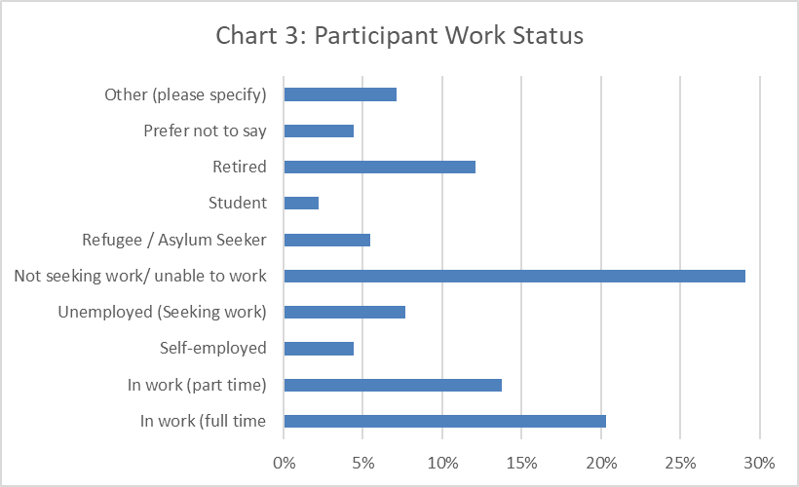

Chart 4 shows the distribution of estimated household incomes, it is worth noting that these are self-reported estimates. We had limited engagement with this question, with 19% selecting “Don’t know” and 15% selecting “Prefer not to say”. Given our focus on low income groups the categories used are focussed on the bottom half of the income distribution (the median household income in 2022 is estimated at £32,300). In essence we are more interested in variations on the bottom end of the income distribution than the top end. It is worth noting that not all categories are the same size. We have good coverage of all income brackets in this survey, the smallest still covering 13 people. Overall we are comfortable that we can carry out meaningful analysis on differences between responses by income bracket.

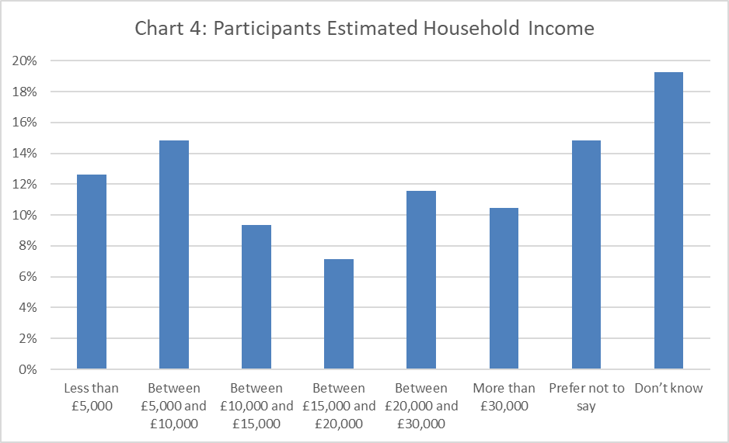

In this research we engaged with participants with a range of different disabilities, shown in Chart 5 below. The most common responses were “No” (36%), “Mental Health Condition” (33%), and “Long Term Illness” (24%). The smallest group was “Visual Impairment” (2%). Overall, we are comfortable that we engaged well with disabled people through this research. Only 8% of respondents selected “Prefer not to say”, showing good engagement with the question. Note that as participants could select multiple options the results add up to more than 100%.

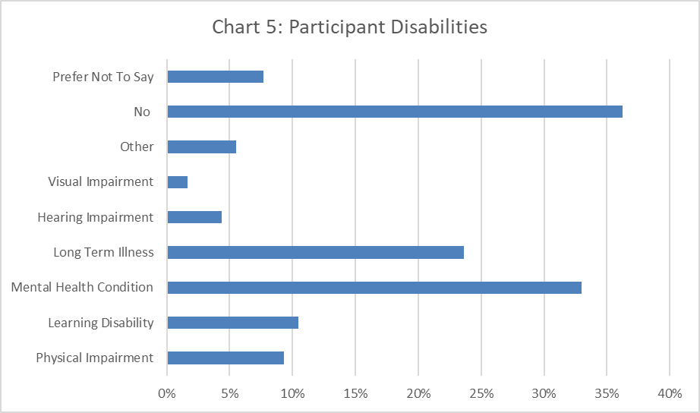

Chart 6 shows the distribution of respondent ages. The median age was 44, with the data broadly following a normal distribution around this. We had low engagement from the 18-24 category (3%), though it should be noted that the narrow age bracket may explain some of this. No respondents were excluded on the grounds of being under 18. Only 9% of respondents selected Prefer not to say, showing good engagement with the question.

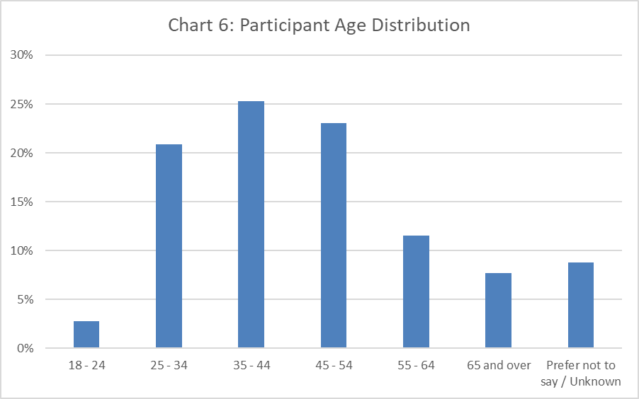

This research engaged with participants across most postcodes in Leeds, with the largest response coming from LS9 and LS10 (16% each.) Of the participants who shared their full postcode, 63% came from the 10% most deprived LSOAs. We had limited engagement with this question, with 19% selecting Prefer not to say. Overall we are confident that we did not unfairly bias any one particular area in our data collection.

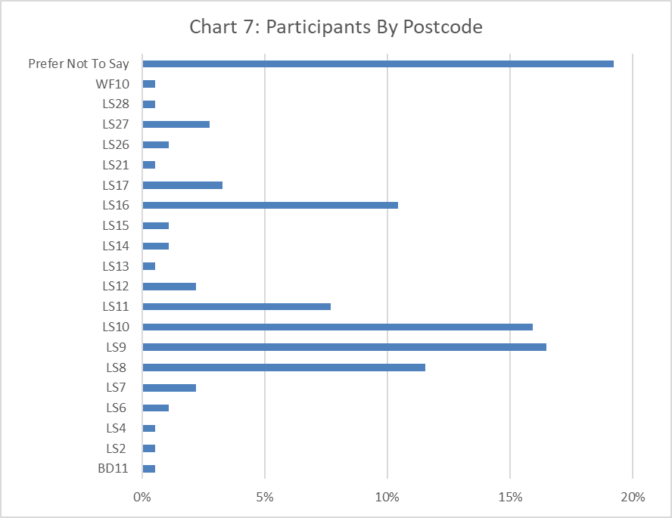

As shown in Chart 8 we mostly engaged with women in this research (82%), with only 32 participants identifying as “Male” (18%) We did not specifically target men or women in our promotion or outreach work, however we clearly engaged more with women in this research. This is an ongoing issue we face when carrying out insight work. In this case we still engaged with enough men that the findings can reflect some of their experiences, however we must be aware of the gender bias within this dataset. Only 1% of respondents selected “Prefer not to say”, showing good engagement with the question.

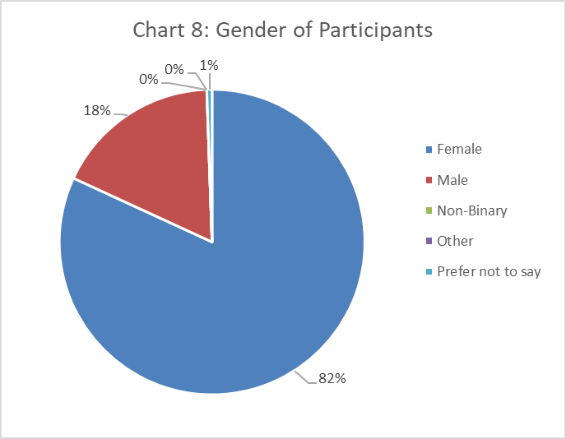

Most participants identified as “Heterosexual/Straight” (87%), with other sexualities accounting for between 1% and 4% of responses each. This is broadly in line with the sexuality statistics for Leeds captured in the 2021 Census, showing that our engagement reflects the demographics of the area. As we were not specifically targeting the LGBT+ community in this research this is in line with our expectations 7% of respondents selected “Prefer not to say”, showing good engagement with the question.

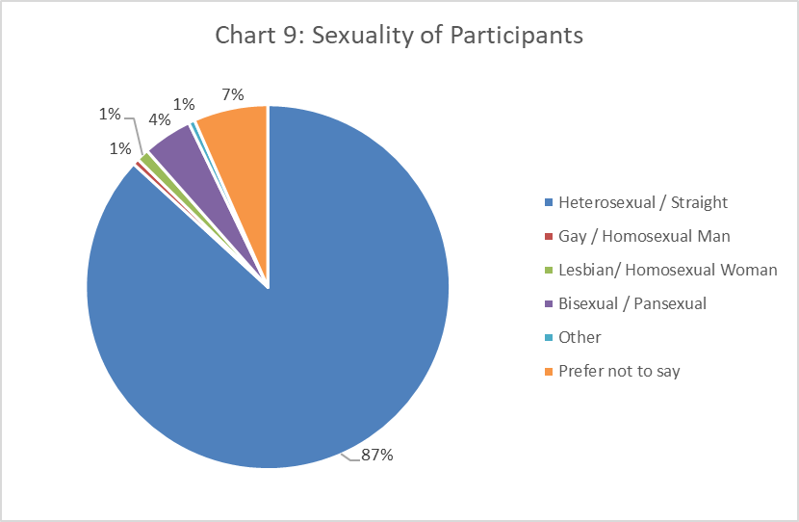

Chart 10 shows the ethnicity of participants. We separated out White British, as it accounts for 46% of all participants its inclusion in the chart would drastically change the scale and make it hard to see the participation rates of other groups. Overall, we engaged with most ethnic groups within Leeds, showing we captured a good spread of experiences from across these different communities. We saw particularly strong engagement from Black Caribbean and Pakistani communities (9% each). 7% of respondents selected “Prefer not to say”, showing good engagement with the question.

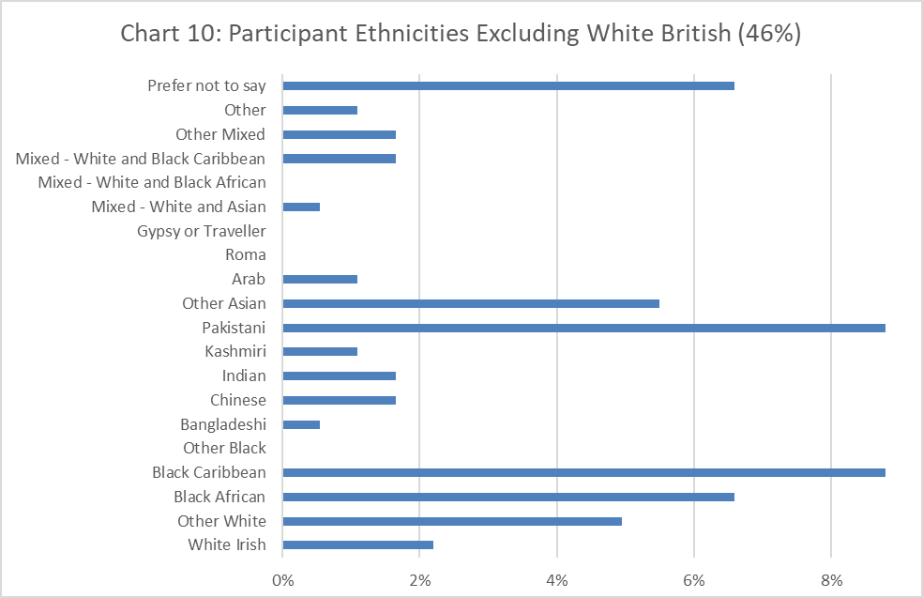

1. Survey Responses

How worried are you about the Cost of Living Crisis?

Chart 11 shows the responses to the question about how worried respondents are about the crisis, as well as how this is broken down across different income brackets. 37% of people who answered this question selected “Extremely Worried”, this was most common among those in the “Below £5,000” group (55%) and “£5-10,000” group (58%). The percentage of respondents decreases as we progress down the rating scale, with only 3% selecting not worried at all. It is worth noting that this trend is driven by the bottom two income brackets as they pull up the average in the “Extremely Worried” response and pull it down in the “Quite Worried” and “A Little Worried” responses. This is unsurprising, as we have discussed in Section 3 those on the lowest incomes are likely to be hit hardest by the crisis. Overall the responses to this question clearly shows that the ‘Cost of Living’ crisis has been a major concern for most participants in this research. 93% of participants answered this question, showing good engagement with the question.

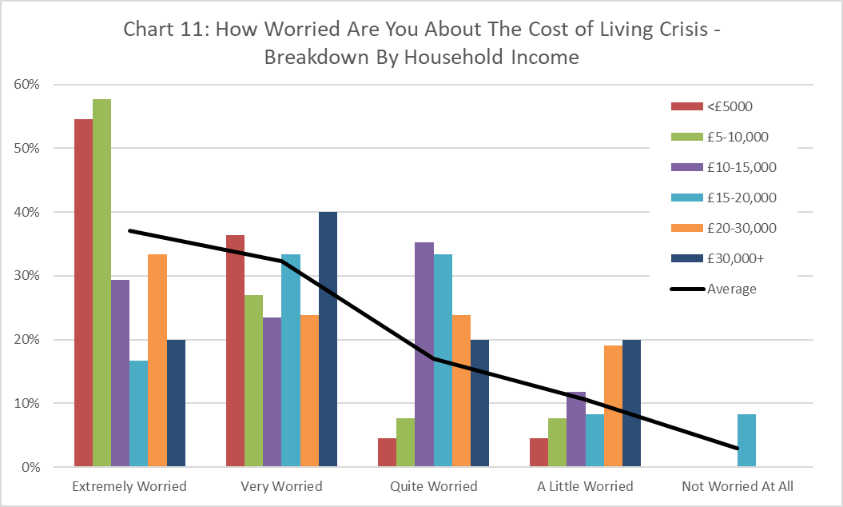

How is it impacting you? For example having to work more, having to change plans, can’t afford food or bills.

82% of participants responded to this question, showing reasonably good engagement with the question. The most common theme in responses to this question was stress over increasing gas and electricity bills, with the majority of responses referencing this. While some respondents simply said that they were worried about it, many referenced severely limiting their use of heating and putting up with their accommodation being extremely cold. One participant said that they would “sit in a cold house until around 8pm” and only turn the heating on for an hour.

Almost as common were comments about food costs. While some mentioned being cautious with spending or cutting back on luxuries or eating out, many talked about having to regularly skip meals or cut back to an extremely limited diet. One participant said they were subsisting on cereal 4 days per week and a large number of participants referenced “struggling to buy food.” Despite this, only a few responses mention accessing foodbanks or similar schemes.

Family was another theme which cropped up in many responses. This took a lot of different forms, including parents worrying about caring for their children, participants needing to support other adult family members, and people needing to rely on family for social and financial support. Several participants referred to having to stay with or move back in with parents due to the crisis. It is clear that in the ‘Cost of Living’ crisis many people are focussed on their familial bonds, both as something to worry about but also as a source of support.

A significant number of participants referenced the impact of the crisis on their health, the most common theme was not being able to heat their homes having a negative impact on their health and exacerbating existing disabilities. Other ways this theme came up included not being able to eat as healthily and one participant said they “had to cancel hospital appointments” because they “couldn’t afford a taxi”. It is worth noting that these preventative healthcare measures can be crucial for maintaining good health outcomes and reduce healthcare costs in the long term. A significant number of responses also referenced a decrease in social contact and not being able to go out to see people.

Relatively few participants mentioned working more in response to the crisis, despite it being one of our prompts for this question. Several responses referenced being unable to work more due to health issues or other commitments restricting their availability.

Unsurprisingly the more extreme responses (such as going without food or heating entirely) were most common in the Below £5,000 and the £5-10,000 income brackets. In the Over £30,000 category the most common responses to this question were focussed on worrying about how it’s affecting others or needing to support family members rather than directly experiencing deprivation.

How is it affecting your mental health? For example stress, difficulty sleeping, effect on mental health conditions

87% of participants responded to this question, showing reasonably good engagement. Increased stress was the most common theme with this question, mentioned in 57% in responses to this question. This often came up alongside difficulty sleeping (mentioned in 33% of responses). This was most often linked to worrying about how to keep up with bills and avoid getting overwhelmed by debt, a substantial number also referenced worrying about family members. Related to this was a significant number of participants who said that they were worried about the future, some saying that they felt hopeless when they looked ahead.

We must note that a significant number of participants responded that they were okay or had not been significantly affected by the ‘Cost of Living’ crisis in this way. While this accounts for only 7% of people who responded to this question, we must recognise that this has not been a universal experience. We must also consider that, even in an anonymised survey, it is possible that the stigma around mental health may lead some participants to downplay their experiences.

Another common theme that arose from this was a worsening of existing mental health conditions (mentioned in 25% of responses), most commonly depression and anxiety. This was often tied to the stress around living costs and worries about family, however a number of responses also referenced increased isolation and a lack of social contact during the crisis as a key factor in this experience. It should also be noted that a small number of participants referenced suicidal ideation or suicide attempts directly related to the ‘Cost of Living’ crisis in their responses.

The main variation across income brackets for this question was around the responses claiming that they were okay. Almost no respondents in the Below £5,000 and the £5-10,000 income brackets reported that they were ok or not feeling an impact on their mental health from the crisis. In all other income brackets there was a relatively even spread of participants responding that they weren’t worried.

Have you accessed any support? For example warm spaces or foodbanks. Has it been helpful?

87% of participants responded to this question, showing reasonably good engagement. There was a reasonably even split in responses between those who had (47%) and those who hadn’t (53%) accessed support during the crisis. Many respondents who say they haven’t accessed services don’t go into more detail about why not. It is worth noting that a significant portion of respondents who say that they haven’t accessed support indicate in other questions that they are struggling, suggesting that there is a significant need not being met by current support services.

Amongst those who responded that they had accessed support the most common theme was using warm spaces. It’s clear from the responses that these were valuable both as a space to keep warm and as a social form of support, giving respondents a reason to go out and be around people without costing money. One participant said that the warm spaces “make a change from sitting alone at home.” Almost as many responses referenced food banks or other ways of supporting food access. The responses which mention these services either don’t comment on how useful the service was or describe it positively, very few people who accessed the services had negative experiences from them.

One theme that came up among those who had not accessed support was an unwillingness to reach out even when struggling to make ends meet. This generally fell into two categories, pride or a feeling that others need it more than they do. Several people stated that they were skipping meals but didn’t want to access support because they could be taking it away from those worse off than them. One participant said that “As an adult I can miss meals. Kids or the elderly can't.” Others explicitly stated that they knew support could help but were too proud to access it. This speaks to enduring stigma around poverty and an unwillingness to reach out.

Another theme amongst those who hadn’t accessed support was that they didn’t know how to find support during the crisis or believed that they wouldn’t be eligible or able to access support. It is often unclear in these responses whether this is due to actual barriers (for example a lack of out of hours support), or simply the perception of respondents. This suggests either substantive or knowledge barriers have restricted people who would have benefitted from support during this crisis.

Participants in the £20-30,000 and More than £30,000 income brackets were much less likely to have accessed support than average. As income increased participants were less likely to say that they had accessed support. However even in the lowest income category a significant proportion of participants hadn’t accessed any support.

What would help you get through this?

85% of participants responded to this question, showing reasonably good engagement. The most common theme in the responses was for food and fuel prices to decrease, or for incomes to rise in line with these costs. While these are obviously not practical requests that could be implemented, it does back up the evidence that food and fuel costs have been the main driver of this ‘Cost of Living’ crisis.

Another common theme was a need for further practical support to help people get through the crisis. This includes the continuation of warm spaces and projects such as food banks, the provision of financial support such as help with energy bills, and increases in benefits to more closely align them with inflation. This covers a wide range of policy decisions, however it clearly shows a need for ongoing practical support from government and organisations working at every level.

There were also some responses which referenced a need for greater emotional and mental health support. For example some participants suggested support groups, or simply expressed a wish that there was someone they could talk to about the challenges they were facing. Tied into this theme were concerns about the future and worries that they didn’t see a way out of this situation.

We did not see any significant differences in the responses to this question between different income brackets, the suggestions seemed consistent across these groups.

Is there anything else you’d like to tell us?

Only 55% of participants responded to this question, showing limited engagement. This is not necessarily an issue as this may suggest that the other questions in this research adequately covered the experiences participants wanted to get across.

The most common response to this question was to say that they had nothing else to share. The responses which didn’t simply state there was nothing to add reinforced themes which already emerged in responses to other questions.

1. Limitations

One of the key limitations of this research was the restricted timeframe within which this data was collected. The survey was open for 44 days (between 18th January and 3rd March.) While this gave us plenty of time to collect data there is a risk that we may have unintentionally biased the research towards peoples experiences during this time period. We did ask participants about their general experiences during the crisis it is possible that if we had collected responses earlier during the year we may have seen different themes arising from participants. For example - we know that the Christmas period can be a very financially stressful time, it is likely that if we had collected survey responses during November and December we would have seen this mentioned. More importantly it is possible that we would have seen other differences in responses which we cannot easily predict and which would have provided valuable additional insight into participants experiences during the crisis. Obviously any challenges which arose after the deadline have not been captured in this research either. The reason for this limitation was practical, given the timeframe within which MHL aims to develop and deliver insight reports it was not feasible to collect data over an extended period of time and track how experiences evolved during the ‘Cost of Living’ crisis.

Another significant limitation to this report is the gender bias in this research, with only 18% of participants being men. This has been a significant challenge throughout all insight reports carried out by MHL over the last 2 years. It is unclear what the main barrier to this has been, however we suggest a few possible factors which may have influenced this.

Stigma around mental health and low engagement with wellbeing focussed work is a persistent problem we face engaging men in service delivery. Within MHL we’ve found that this can be addressed by investing time with service users to build up trust and encourage men to open up about their experiences. Due to the limited timeframe and resources of this insight report we were not able to set aside the time needed to do this form of in-depth outreach and relationship building. A change in the language used in the survey may have helped address this issue, by putting the questions in terms men may be more comfortable talking about.

It is also possible that there is a bias in the networks and outreach we used to promote the survey. Due to the range of methods used for this and the number of different networks, organisations, and individuals involved in disseminating the survey it is hard to accurately estimate what percentage of people who saw the advert were men. It is possible that this affected our engagement with men in this research, and other than engaging with Mens Health Unlocked we did not plan outreach specifically targeted at men to address this issue. Men were not identified as a target population we were specifically focussed on during this research, so outreach planning was more focussed on engaging with people on low incomes.

Based on discussions with colleagues specialised in men’s work and reflections on our experiences in this and previous insight reports, it’s clear that we need to adjust our approach to engage with men. Surveys carried out by MHL have consistently struggled to engage with men, potentially a focus group approach with space to build trust and develop rapport would be a more effective approach. However it is worth noting that this would be a significantly more labour intensive approach to data collection and would require a decreased overall sample size or the commitment of greater resources.

1. Recommendations
2. One of the key findings from this report is that **practical help during this crisis has had a strong positive impact**. Feedback through this research shows that the warm spaces scheme and food banks (or similar food projects) have been a great help to those who have accessed them during this crisis. The warm spaces scheme had the additional benefit of providing social support in a time when many people were having to cut back on going out or other leisure activities. This gives strong support for the continuation of these services throughout the crisis.
3. **Barriers to accessing support** were clearly identified in this report. The **stigma around poverty and** reaching out for help affected many participants, with some explicitly saying that they were too proud to access the help they needed. **Changing the language** used to promote some of the support spaces to less closely associate them with deprivation or poverty may help mitigate this issue. In the long term this could be addressed on a more strategic level by **addressing the enduring stigma around poverty**, in a similar way to anti-stigma work around mental health.
4. There was a common perception amongst participants that they wouldn’t be eligible for the support they needed, that they weren’t a priority and accessing the support would mean there was no space for others who needed it more, or simply that they didn’t know where to look for support. **Clearer messaging around who can access support and more aggressive promotion of the spaces could help address these issues**.
5. **This situation is likely to continue**. As we move out of the winter months the pressure from fuel bills will alleviate and some of the worst effects of the ‘Cost of Living’ crisis will ease. However until inflation drops and incomes catch up with the increases in food and fuel prices the ‘Cost of Living’ crisis can still be said to be ongoing. If this isn’t resolved by the autumn of 2023, as heating once again becomes a more significant cost, we could see a return to the situation described in this report. More specifically **we need to see a decrease in prices or an increase in the incomes of those on the bottom of the income distribution to bring us out of the ‘Cost of Living’ crisis**.

1. The impact of the ‘Cost of Living’ crisis on the **mental health** of participants is clearly shown in this research. This was most often described as **increased stress**, often manifesting in **difficulty sleeping** and a **worsening of existing mental health issues.** It is possible that the provision of stress management training or resources could help mitigate these mental health impacts. However this approach could only function as harm reduction unless it’s combined with policies to address the underlying problem of the ‘Cost of Living’ crisis.
2. Conclusion

The ‘Cost of Living’ crisis has affected everyone who participated in this survey, driven by inflation in general and the sharp rise in food and fuel prices in particular. This has affected people in different ways, ranging from cutting back on leisure activities to making hard choices about whether to heat their home or eat. This has been an intensely stressful time for many people, with a substantial effect on their mental health tied to the economic strain it has placed on them. Our findings around this are backed up by existing research on poverty and mental health.

From the responses to our survey we can see that this crisis is hitting those with an estimated household income below £10,000 the hardest. We see a distinct pattern in the questions “How worried are you about the Cost of Living Crisis?”, “How is it impacting you?”, and “How is it affecting your mental health?”. The bottom two income brackets were far more likely to give more extreme responses, reflecting that people on low incomes tended to be more stressed about the crisis, and be more heavily affected by it both in terms of material impact and the effect on mental health. As covered in the background section this is unsurprising given the composition of inflation over the past year, and their general vulnerability of people on low incomes to economic shocks, however this finding is useful in identifying the threshold at which the most acute impacts are being felt.

A positive takeaway is that the participants who have accessed support during the crisis have generally found it to be helpful. Foodbanks and warm spaces have been effective at alleviating some of the worst impacts of the crisis, warm spaces in particular have been effective in alleviating some of the social isolation which has been a part of the crisis. However there were also significant barriers which stopped people who could have benefitted from support from reaching out. This included difficulty finding information about support, thinking that they shouldn’t access support because others need it more, or not reaching out because they were ashamed of needing help. Clearly there is more work to do to ensure that help is reaching those who need it.

Our hope is that this research can be useful both to better understand how people have been affected by this crisis, and to build knowledge of what interventions may be effective in mitigating similar situations in the future. One point which stands out clearly throughout this research is the link between economic deprivation and mental health, supporting MHLs underlying goal of promoting better mental health by working with the 10% most deprived communities.

1. Further Reading

Braun, V., & Clarke, V. (2006). Using Thematic Analysis in Psychology. *Qualitative Research in Psychology*, *3*(2), 77–101.

Department for Work & Pensions (DWP). (2023). Households below average income: for financial years ending 1995 to 2022.

Edmiston, D., Hyde, E., & Adnan-Smith, T. (2022). *The cost of not living: everyday financial crisis in Leeds*. University of Leeds

Elliott, I. (2016). *Poverty and mental health*. Mental Health Foundation.

Fogden, R., Buck, D., Franklin, B., & Lewis, T. (2022). *Poverty and the health and care system: The role of data and partnership in bringing change*. Centre for Progressive Policy.

Joseph Rowntree Foundation. (2023). *The essential guide to understanding poverty in the UK*.

Joseph Rowntree Foundation. (2023). *Destitution in the UK: income thresholds for October 2022*.

Knifton, L., & Inglis, G. (2020). Poverty and mental health: policy, practice and research implications. *BJPsych Bulletin*, *44*(5), 193–196.

Lee, A., Sinha, I., Boyce, T., Allen, J., & Goldblatt, P. (2022). *Fuel Poverty, Cold Homes And Health Inequalities In The UK*. Institute of Health Equity.

Mind. (2021). *Mind: Fighting for the MH of people living in poverty*.

Murali, V., & Oyebode, F. (2004). Poverty, social inequality and mental health. In *Advances in Psychiatric Treatment* (Vol. 10, Issue 3, pp. 216–224).

Office for National Statistics (ONS). (2023). Average weekly earnings in Great Britain: March 2023

The Guardian. (2023.) *The Heat and Eat Diaries*. Accessed at https://www.theguardian.com/commentisfree/series/the-heat-or-eat-diaries

The Health Foundation. (2022). *Quantifying health inequalities in England*.

1. Appendices

10.1) Appendix 1: Questionnaire

10.2) Appendix 2: Flyer

