

Disability During The Pandemic:

How has the pandemic specifically affected the lives and mental health of disabled people in Leeds?



By Quenby Harley

Community Health Development Analyst – Data & Intelligence

Mentally Healthy Leeds

June 2023

Table of Contents

Title Page 1

Contents 2

1) Executive Summary 3

2) Introduction 5

3) Background 6

4) Methodology 8

5) Demographics 12

6) Survey Responses 17

7) Limitations 29

8) Recommendations 30

9) Conclusion 32

10) Further Reading 33

11) Appendices 35

1. Executive Summary

This report looks into how disabled people have been particularly affected by the pandemic. We used a survey method to identify ways in which COVID and the policies and precautions associated with it have disproportionately impacted people living with various disabilities across a range of different areas. We aimed to capture both positive and negative parts of this experience whilst reflecting on the variety in participants responses.

**Key Findings and Recommendations**

**Healthcare** – 57% of participants reported a worse experience of healthcare during the pandemic. The most common issues were difficulty getting appointments, and no longer having appointments in person. However, some responses also highlighted the increased availability of online and phone appointments as a positive.

In this research we have seen that moving towards online and phone appointments have helped some but excluded others who have struggled to adapt to these approaches. **Moving forward a hybrid approach offering online, phone, and in person support could give patients better support by improving the accessibility of healthcare.**

**Work –** 45% of participants said their experience of work improved during the pandemic. The main factor in this was the shift towards working from home, with many participants identifying it as an important adjustment which made work significantly more accessible. However, this was not a universal experience, with some participants feeling increasingly isolated when working from home.

There remain significant challenges to be addressed, including adapting management and putting strategies in place to protect workers from isolation. Our view is that despite these challenges, the adaptations put in place by many workplaces gave an unprecedented opportunity to experiment with ways of working. From this we can learn what works and what doesn’t work and use that to inform more inclusive and accessible ways of working moving forward. **We recommend that commissioned services lead by example, offering flexible ways of working and developing good practice which other employers can learn from.**

**Isolation and Loneliness** **–** 57% of participants said the way they socialised got worse during the pandemic, and 62% said that they were more lonely – most commonly this was tied to shrinking social circles and an inability to go out to in person events. Some participants said that the shift towards more things being online had been good for them but felt that a lot of that progress had been undone as the rest of the world moves back towards a ‘business as usual’ approach.

We have an opportunity to use these tools and knowledge developed during the pandemic to build more accessible ways to socialise and reduce isolation and loneliness for many disabled people. **Integrating online social spaces and activities into service delivery could play a valuable role in supporting disabled people’s mental health.**

**Afterthought –** 70% of participants said their experience in public spaces worsened, and 69% felt that the government hadn’t thought about them at all. Thiswas a common theme throughout this research, with a theme of being overlooked or forgotten about popping in responses to questions throughout the survey, most prominently in the feedback around the accessibility of public spaces.

Treating disability and accessibility as an inconvenience or an afterthought is a long term problem in decision making at every level. This is a key area where there remains important learning to be done to improve our inclusivity. **For commissioners and service providers this could include a review of service accessibility and an explicit focus on disability when evaluating service provision.**

**Varied Experiences –** It was clear that different participants have very different disabilities, needs, and circumstances which shaped how the pandemic affected them. Changes which were positive adaptations for some created additional barriers for others. Above all this report shows that there is no one-size-fits-all approach to improving accessibility, flexibility and individual approaches are vital to improving disabled lives.

1. Introduction

The pandemic affected people throughout society, but the impact was not spread evenly across the population. As is often the case, people who face various forms of marginalisation were affected more acutely by the social, economic, and healthcare impacts of COVID-19. In this insight report we try to identify key ways in which the pandemic affected disabled people in particular. As part of this work we intended to better understand the issues affecting disabled people during the pandemic, but also to identify any beneficial side effects of the changes in daily life which took place over this time period.

Our core research question was ‘How has the pandemic specifically affected the lives and mental health of disabled people in Leeds?’ The question and methodology were developed in collaboration between Mentally Healthy Leeds and commissioners working in Leeds Public Health. An interest was expressed in engaging with people living with a range of different disabilities. We were keen to capture the nuanced and at times contradictory experiences that different disabled people have lived through during this period.

1. Background

For this research we have used the definition of disability laid out by the Equality Act of 2010 – “a physical or mental impairment that has a ‘substantial’ and ‘long-term’ negative effect on your ability to do normal daily activities.” We have relied on self-reporting from research participants to collect data on different disabilities and at no point have we asked for evidence of the condition or diagnosis. This was a conscious decision as we judged the risk of alienating potential participants by interrogating their identities to outweigh any potential benefits. There were also concerns that intrusive questioning could bring up traumatic experiences for participants, given the denial many disabled people face when they talk about their experiences. This could both undermine the quality of the data collected and have ethical implications for the research.

A topic which came up in our research was the distinction between the social and medical models of disability. It is not within the remit of this report to make any judgements around which is the better approach to understand disability or support disabled people. Nor will we be engaging in the academic debates around the exact formulation of the different models. We are outlining the broad concepts as we have found them to be a useful tools for looking at disability and inclusion from different perspectives and using these lenses to assess our preconception:

* The medical model views disability as a problem with an individual’s body or mind which restricts their ability to function normally
* The social model sees disability as existing within the context of a society. Individuals may have impairments, but it is the attitudes and structures of society which excludes them and makes them disabled.

Disability has been an important part of the conversation around COVID, mostly focussed on the issue of Long COVID. This is a term which was coined by patients rather than doctors, at time of publication there is no broadly accepted clinical definition of Long COVID. Instead, it can be described as a collection of long term health conditions which some people develop after contracting the COVID-19 virus, most commonly presenting as fatigue, cognitive dysfunction, joint and muscle pain. Links have also been drawn between Long COVID and Myalgic Encephalomyelitis/Chronic Fatigue Syndrome (ME/CFS). It is important to note that while this research was open to people who developed Long COVID it was also open to people who never contracted COVID or developed this condition.

Though less prevalent in the news than Long COVID, other work has been done looking at how disabled people were affected by the pandemic. In Leeds Healthwatch published regular bulletins capturing a range of perspectives around the topic of “How does it feel for me during COVID-19”, including several themed around disabled perspectives. There has also been an array of news articles, reports, and some academic research around the topic of how disabled people have been affected by the pandemic. Reading around this was used to shape our understanding of the issues and in turn helped inform the methodology used in this insight report.

The findings of this report must also be understood in the context of broader issues facing disabled people. This report will not go into much detail around this, both because it lies beyond the scope of this research and because there is already a wealth of research on these issues. According to the Office For National Statistics (ONS) disabled people are less likely to be working, less likely to achieve qualifications, more likely to live in social housing, more likely to regularly feel lonely, and generally have poorer ratings in wellbeing metrics. Studies have also shown that day to day activities are often more expensive and generally more complicated for disabled people.

1. Methodology

From the start we were keen to reflect Touchstone’s values of coproduction and a person centred approach in this research. We recognise that the pandemic has been a stressful and traumatic experience for many people, as such we wanted to be sensitive in how we approached these topics. In addition to this many disabled people have trauma related to their disability, or how they have been treated because of their disability. We tried to keep this in mind when carrying out this research as well.

Research into disabled experiences also has a complex history. Studies of disability have often been criticised for embedding ableist biases within their methodologies or treating disabled people in disempowering or dehumanising ways. A common phrase we came across in relation to this issue is “nothing about us without us”. This refers to a desire for disabled voices to be engaged with, fairly represented, and listened to at every level – rather than simply being reduced to a subject for non-disabled people to study. Our intention throughout this research has been to work with disabled people to capture their perspectives of the pandemic and understand what they’ve been through on their own terms. We were mindful of these issues when designing the research and in the ways we promoted it to potential participants.

4.1) Designing Question Set

The first stage of the research was designing the question set. This was done through a combination of background reading and consultations with a range of people who had experience around disability. This included a mixture of professional and lived experience to help shape our approach to the core research question. From this combination of consultations and reading we identified four key areas which had been affected (healthcare, social care, accessibility, and isolation), from these we began to develop the questionnaire used to collect data. Through these conversations a fifth issue came up running through the rest of the practical issues - a sense that disabled people had been forgotten about or left behind in conversations and policy decisions around the pandemic.

Coproduction was a core principle underpinning this process. As well as carrying out background research and discussing the topic with professionals we also actively sought out input from disabled people. This included conversations with disabled colleagues within Touchstone and across our wider professional network to discuss the challenges they experienced during the pandemic and to review the wording and layout of the questions used in the survey. We also reached out to several disability campaigning and support groups within Leeds to discuss the question set, though we had limited responses from these groups.

The full paper version of the questionnaire is included as Appendix 1 for reference. In section 1 of the questionnaire, we used our standard set of demographics questions, asking participants to disclose information around age, disability, gender, sexuality, ethnicity, and postcode. This was collected to characterise the sample population and evaluate how effectively we engaged with a diverse set of participants. The only adaptation made to this was adding an open question box where participants could disclose more details of their disability, which could be used to provide greater context for their answers.

For most questions our approach was to combine a simple rating scale with an open follow-up question to capture qualitative information relating to this. We also used examples to help frame the questions and generate more consistency in how participants approached them. We used multiple examples for each of these questions to try and minimise biasing respondents towards any single perspective. An example of this kind of question is shown in Figure 1 below.

Figure 1: Example of question layout

We also asked two standalone open questions (“Is there anything else you’d like to tell us?” and “Overall, how have you felt during the pandemic?”) The first of these gave an opening for participants to share any thoughts that weren’t covered by our questions and capture perspectives which could otherwise be overlooked. The second provided an open space to express complex feelings and struggles which couldn’t be expressed in a simple linear scale as used for the rest of the questions.

4.2 Accessibility

Given the subject of this insight report, accessibility was obviously an important consideration when designing the questionnaire. We went through several iterations of questions, refining through feedback from commissioners and discussions with people we spoke to during the consultation stage. The aim with this process was to fill in any gaps in the question set and refine the wording to express our questions clearly in the simplest possible language to improve accessibility.

We used resources on how to create easy read documents to design the questionnaire. The font, layout, and use of pictures through the document were designed to make the information as easy to process as possible. The use of emoticons on the rating scale was also used to make it more accessible, and less abstract than a numerical scale. We also ran the questionnaire through a screen reader program to check that it made sense for visually impaired participants relying on that adaptation.

As well as being available as a paper copy, we adapted the questionnaire to work in different formats. This included converting it onto an online version on SurveyMonkey which was easier to link to through posters and flyers (as can be seen in Appendix 2, we used a QR code which could be scanned to go directly to the online survey.) We also planned ways in which we could support people with varying access needs to complete the questionnaire and offered to carry out the research through conversation for anyone who would be more comfortable working like that. This flexibility was made clear in all our advertising and outreach work.

4.3) Outreach

We carried out extensive outreach work to promote this research through professional networks, to relevant groups, and to individuals. The full list can be found in Appendix 3. This included making using of professional networks, attending disability groups in person, reaching out to services and activist groups working around disability, using social media, and sharing flyers around various locations including some GPs and pharmacies. When concerns were raised during data collection at the underrepresentation of men and BME communities we also carried focussed outreach targeted at those communities, with limited success.

4.4) Analysis

The quantitative and demographic data collected was compiled and analysed on a question by question basis as shown in the results section below. The qualitative open questions were subjected to thematic analysis, as shown in the results section below. This process involves grouping responses and identifying the common themes which naturally emerge from the collected responses. From this we were able to synthesise a large amount of qualitative data into relatively simple information.

1. Demographics

There were 52 participants in this study, with responses gathered from July to September 2022. Despite the offer to provide support for participants or carry out in person research as an alternative, this offer was not taken up by any participants. All data is self reported, we did not require evidence of identity or medical diagnoses to validate any of the details. No participants were excluded from this research for falling outside of the remit of this insight report.

As shown in Chart 1 participants had a range of different disabilities, with Mental Health Condition (60%), Physical Impairment (44%), and Long Term Illness (42%) as the most common categories of disability. It is worth noting that even the least common categories (Visual and Hearing Impairments) had 5 participants (10%). The figures add up to more than 100% as many of the participants had more than one disability. Overall we are confident that we have covered a good range of different disabilities. 100% of participants completed this question.

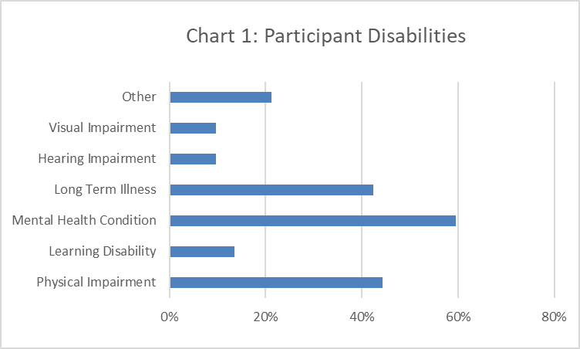

As shown in Chart 2, we had an uneven age distribution, with no participants between the ages of 18 and 24. We also had no participants below the age of 18, which is good as this research was specifically intended not to work with that age group. Other age categories ranged from 8% (55-64) to 42% (25-34), with no identifiable distribution within this data set. Overall we have an uneven spread of responses from different age groups, with a significant gap in coverage for the 18-24 category. 100% of participants completed this question. This bias towards engaging with older people in this research may reflect the relationship between age and disability. In the 2021 Census the ONS explicitly states that people are more likely to be disabled as they get older, this may go some way to explaining the lack of participants in the under 25 age bracket.

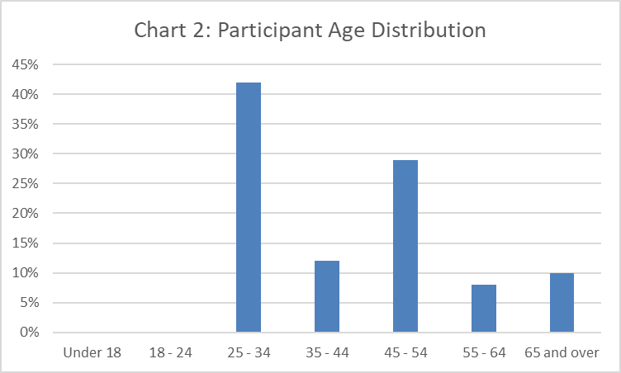

Chart 3 shows that participants came from across Leeds, with 21 different postcodes from across Leeds being recorded and no single postcode accounting for more than 10% of participants. We regard this as a good geographical spread within our remit to work across Leeds on this insight report. 90% of participants answered this question, with 5 (10%) either not completing the question or indicating that they’d prefer not to disclose this. Nobody was excluded for living outside of the target area.

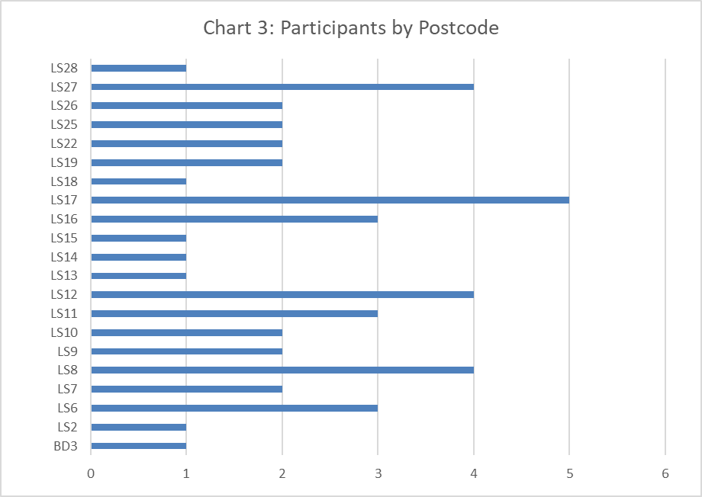

The majority of participants were female (58%), with male (27%) as the next most common. This shows a distinct bias towards woman which is a potential weakness to this research. It is worth noting that our outreach did not specifically target women, and when this bias was identified we carried out targeted outreach to engage with more men and saw an improvement in male representation as a result of this. The overrepresentation of women in this research is not so large that we feel it is only applicable to that demographic. 100% of participants answered this question.

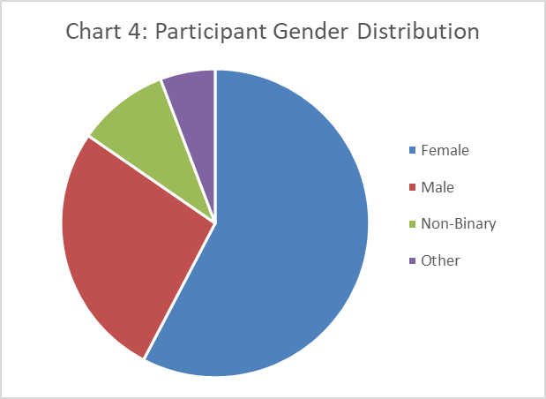

54% of participants identified as Heterosexual, with Bisexual/Pansexual as the next most common identity (27%). We are comfortable that we engaged with a diverse range of people with regards to sexuality. 96% of participants disclosed their sexuality, while 4% selected Prefer not to say.

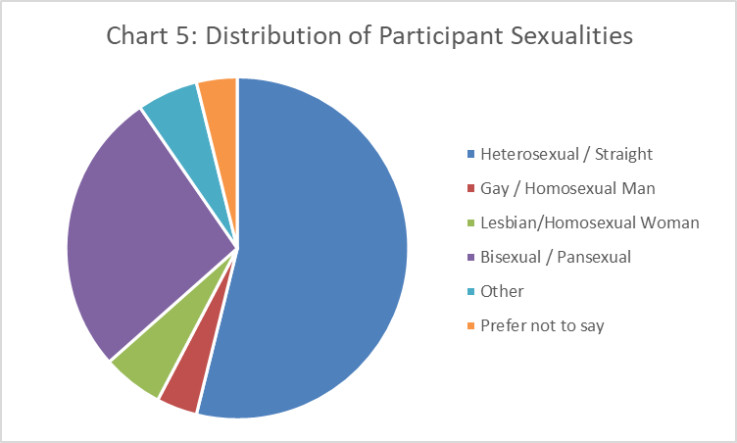

83% of participants were White English/Welsh/Scottish/Northern Irish/British, with an additional 4% identifying as “Other White”. 6% of participants were Pakistani and 8% were Kashmiri. This research broadly failed to engage with diverse ethnic populations, this a serious issue which is discussed further in the limitations section. 100% of participants answered the question. When initially promoting this research we did not intentionally target any particular ethnic groups, our strategy was to engage with service users engaged with a broad range of health and wellbeing service, with specific outreach targeted towards groups and projects with a focus on disability. When the lack of ethnic diversity in our responses began to become clear in the data collection phase, we did send out additional promotions specifically asking for engagement from BME communities and reaching out to BME groups, however as the data clearly shows this was ineffective. In previous reports we have had success working in collaboration with organisations such as HOPE Bereavement Services, which works specifically around bereavement within the South Asian community. Unfortunately we were unable to identify any similar groups or organisations focussed on disability within BME communities.

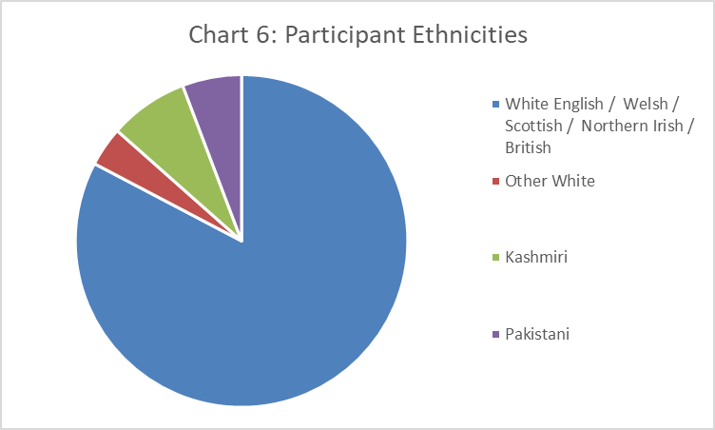

1. Survey Responses

We will go through the substantive survey responses question by question. Where a rating scale was used these will be displayed graphically and briefly characterised, as demonstrated in the demographics section, we will then combine this with the qualitative data processed using thematic analysis.

6.1) Healthcare

87% of participants answered the healthcare question shown in Chart 7 below. 33% stated that their experience of healthcare got a lot worse, with an additional 24% saying it got a bit worse. It seems clear from this data that a lower standard of healthcare was the prevailing experience during this period, however it is worth noting that 29% also reported mixed or unchanged experiences.

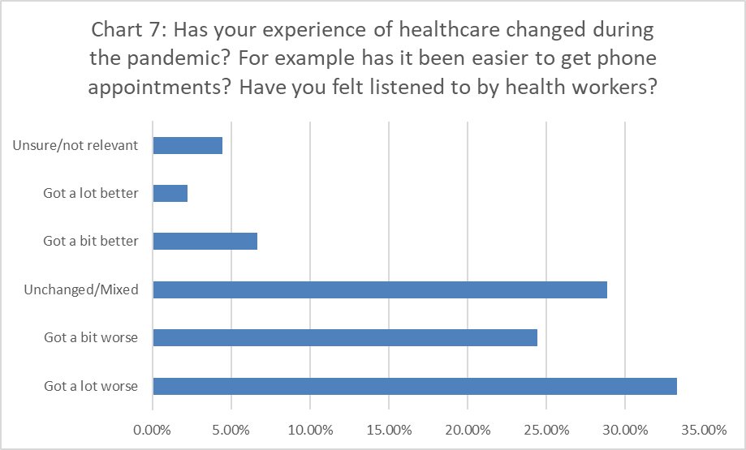

82% of participants who answered this question chose to disclose further details. The most common themes were difficulty getting appointments and increased waiting times to access specialist or emergency care. The shift towards phone appointments for GPs has worsened accessibility for some, anxiety and hearing difficulties have made it hard for some to adapt to this change.

One participant said “I didn't like having all my appointments on the phone during Covid as this meant I was ignored, not listened to and turned away from services … I had hospital surgeries cancelled due to covid and wasn't added back on the list.”

Several participants also referenced being less likely to try and access healthcare altogether. In several cases participants claim that the decreased availability of timely health interventions had significant knock-on effects to their long-term health. Some participants who reported unchanged and mixed experiences commented that they “rarely had a good experience of the healthcare system in the UK” to begin with and their experience during the pandemic had remained mostly poor.

It is worth noting that some participants did state that the increased availability of telephone and online appointments were convenient for them when they did manage to book an appointment. As one participant put it “As someone who has trouble leaving the house, having healthcare services be willing to speak over the phone has been much more convenient for me.”

6.2) Social Care

85% of participants responded to the question about care shown in Chart 8 below, of these 68% responded with Unsure/not relevant. This suggests that many of our participants may not have or need access to care workers. 11% stated that their experience of care got a lot worse, while 16% reported unchanged or mixed experiences. The low engagement with this question makes it hard to draw strong conclusions, however it does suggest that very few people have seen their care provision improve during the pandemic.

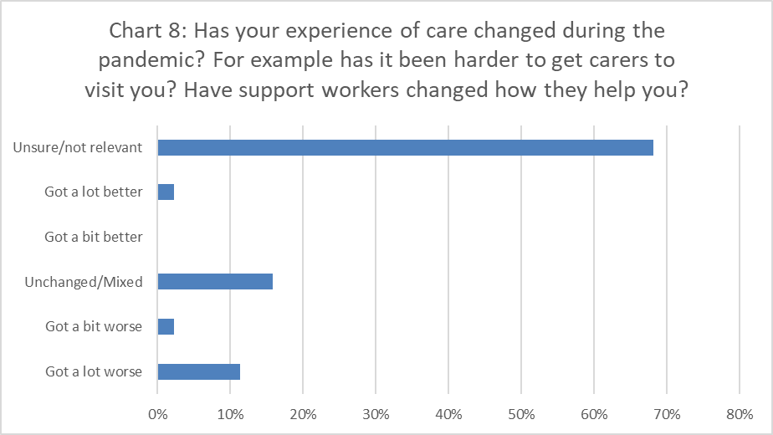

38% of participants who answered this question chose to disclose additional information. Many of these responses were simple confirmation that they did not need or did not have access to care or support workers. The main concern which arose from the thematic analysis was inadequate COVID precautions. Several participants stated that they felt unsafe and ceased accessing care due to unwillingness to wear masks or use appropriate precautions.

One participant shared that they “don't dare to try and get [carers] because of how massive a struggle it is to get people to wear a mask.” Again, it is worth noting that we are working from a relatively limited dataset with these responses, so the thematic analysis is someone limited with regards to this question.

6.3) Work

83% of participants responded to the question about work shown in Chart 9 below, of these 26% respondents selected Unsure/not relevant. 19% said that their experience had got a lot better, with a further 26% saying it was a bit better. We then see a fairly consistent drop off from Unchanged/Mixed (16%) to got a lot worse (5%). Overall this data suggests that respondents experience of work tended to improve during the pandemic, though this is certainly not a universal experience within our dataset.

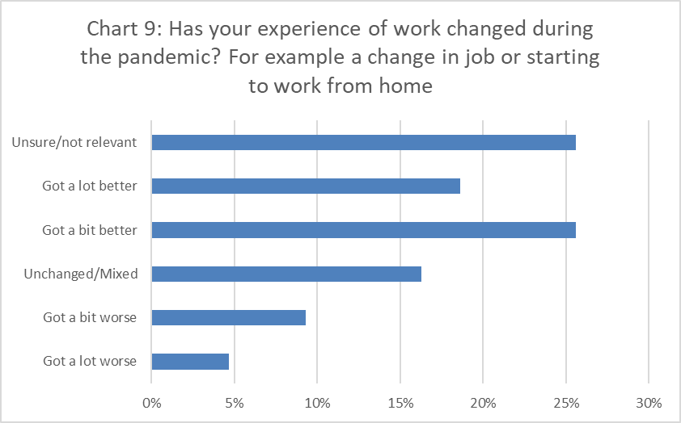

72% of participants who responded to this question chose to disclose additional information. The most common theme that arose from these answers was improved accessibility and productivity when working from home. This took different forms but included being able to focus more, greater control over their working environment, and not having to travel as much. Notably many of the people who referenced working from home stated that this shift towards working from home was beneficial to them more generally, not simply during the pandemic.

One participant said that “working from home was a reasonable adjustment I requested many times before the pandemic, but it was rarely agreed to. Now it is almost normal and it saves me so much energy and stress.” At the same time many participants also referenced feeling more isolated and their mental health worsening while working from home, with one participant describing working from home as “very lonely” and making it “much harder for me to manage a work/life balance”. Often this was mentioned in conjunction with another theme, managers not being able to offer appropriate support when suddenly transitioning to working from home.

The ways that the shift to working from home benefitted so many participants and improved the accessibility of work raises some important questions about the long term potential of working from home for disabled people. While there are clearly still issues which need to be addressed around this, we identify this as an important area for further research looking beyond the pandemic. Broader national research around the experiences of work during the pandemic identify similar themes. The shift in working patterns and transition towards working from home and hybrid working arrangements have impacted workers across the UK, whether they are disabled or not. However research into disabled workers across the UK highlights the additional challenges of new forms of reasonable adjustments being required when working from home, as well as the continuation of existing challenges for disabled workers. On the other side of this the shift to working from home also has the potential for disabled workers to see more significant improvements in working conditions and productivity than non-disabled counterparts.

6.4) Socialising and Loneliness

85% of participants responded to the question shown in Chart 10 below. As is clearly visible the majority of these participants responded that the ways they socialise have got a lot worse (30%) or a bit worse (27%) during the pandemic. The responses drop off consistently as the ratings become more positive. It is worth noting despite this distinct trend the “got a lot better” response still accounts for 7% of responses and “got a bit better” for 14%. While less common it still represents a significant group of positive responses to the social changes during the pandemic.

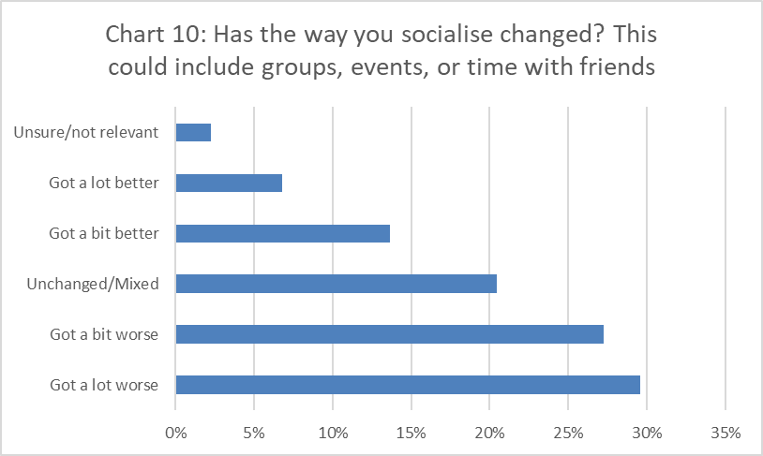

75% of participants who responded to this question chose to disclose additional information. Nearly every one of the in-depth responses referenced a shift towards online socialising through social media and Zoom. What varied a great deal within these responses was people’s feelings about this shift. One participant also raised the issue of social activities moving back to being in-person too early, saying that “some activities went online which really suited me but most have now reverted to in person and often I can't attend at all”. While some people found this was more accessible in some ways others felt excluded because they weren’t comfortable using these new approaches to keep in touch with friends. Overall there was no clear consensus about whether this was a positive or negative change.

Many participants stated that they felt a lot more anxious socialising during the pandemic, both because of worries about infection and a loss of social skills due to isolation, as one participant put it, they “struggle with things being loud after 2 years in the quiet”. Most participants stated that they socialised in person much less over the last 2 years, with some still shielding at home. One participant said that they “have had to be very careful regarding mixing with other people and socialising.” Several participants referenced that their boundaries shifted during the pandemic, and they saw a shrinking of their social circles as they prioritised a few core friendships to the detriment of other connections.

One participant felt that “the pandemic really brought into light what I need from friendships, my capacity for friendships, and who my real friends were.“ It is worth noting that several participants stated that they hadn’t seen much change as they were already very isolated before the pandemic. Overall it seems that most people who took part in our survey have seen their social circles shrinking, becoming more isolated and less comfortable socialising.

87% of participants answered the question displayed in Chart 11 below, it is worth noting the connection between this question and the question about socialising in chart 10 above, as isolation was a major theme in responses to that. The most common response was “A bit more lonely” (38%), followed by “A lot more lonely” (24%) and “unchanged/mixed” (20%). In contrast relatively few responded with “a bit less lonely” (7%) or “much less lonely” (4%). Overall it draws a clear pattern that most participants felt more lonely or isolated during the pandemic.

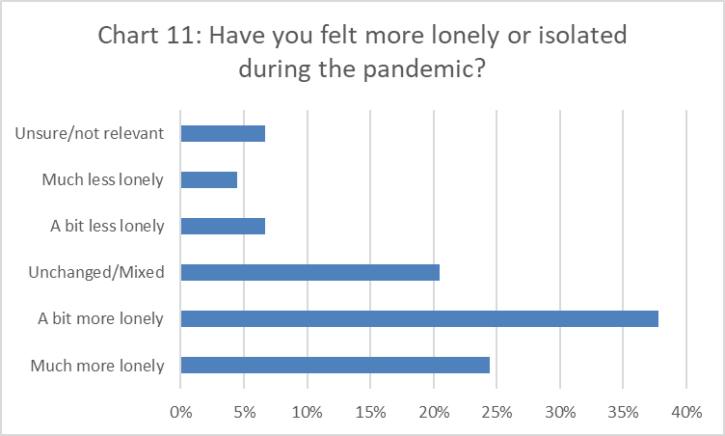

Only 53% of participants who answered this question chose to disclose additional information. Many reiterated the themes identified in response to the question around changes in socialising. The effect of moving online left many people who struggled with technologies feeling more isolated. Conversely, some participants say that since many things have shifted back towards in person events and services, they’ve felt excluded as they didn’t feel able to return to that level of exposure. One participant said that “the lockdown itself was ok because everyone was in the same situation and there were lots of online activities to do, but now everyone is back to in-person.” It is also worth noting that some participants reported that they were already very isolated prior to the pandemic, and they hadn’t seen much change. As one participant put it “I'm not sure how much this was to do with the pandemic and how much was normal mental health struggles.”

6.5) Changes At Home

84% of participants responded to this question, of these 25% selected unsure/not relevant. 34% of those who responded to the question said things were unchanged/mixed, with 23% saying that things had got a little worse. The remaining categories account for between 5% and 7% of responses each. This suggests that most people saw no change or a moderate decline in their living situation during the pandemic. The large proportion selecting unsure/not relevant suggests that this question may not have been well framed.

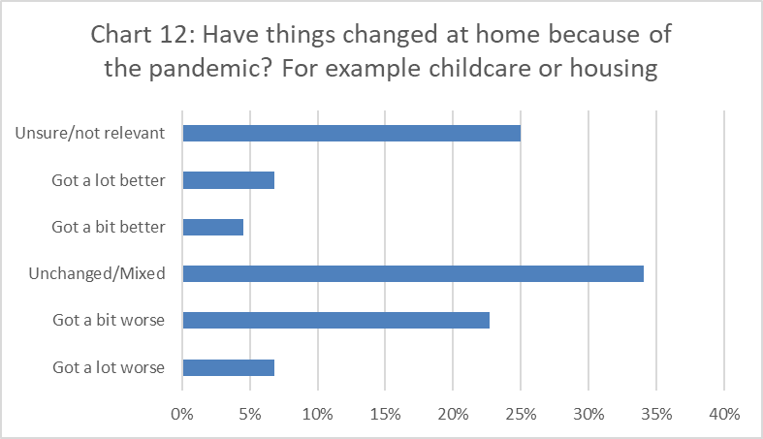

Only 50% of those who responded chose to disclose additional information. Many of the issues raised in these comments are not necessarily related to the pandemic, for example issues with neighbours or the effect of increases in the cost of living. One theme which did come out in these responses was increased stress from being at home more due to lockdowns and an increase in working and studying from home. For some participants this had a significant impact on their mental health and relationships. Several responses also referenced difficulties accessing adequate childcare during the pandemic as an additional source of stress at home. One participant shared that “6 months without any form of childcare at the start of the pandemic and first lockdown which was extremely difficult.”

6.6) Public Spaces

85% of participants responded to the question in Chart 13. The most common response was got a bit worse (43%), followed by a lot worse (27%), and unchanged/mixed (18%). Only 4% rated their experiences as getting a bit better or a lot better. This shows that most participants found their experiences in public spaces worsening during the pandemic, with few counter indications.

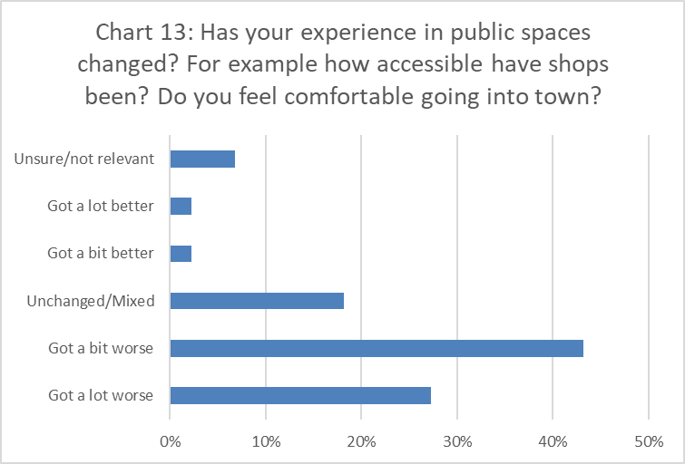

68% of participants who responded to the question chose to disclose further information. As with previous questions increased anxiety was a theme which emerged from these responses, many participants said they are less likely to go out in public because of this and have become more isolated and reliant on online alternatives. Some participants linked this to another theme, concerns that COVID precautions have been lifted too soon. For many disabled people this carries a higher risk, in particular immunocompromised and immunosuppressed people. One participant said that “places instantly stopped doing all safety precautions the millisecond they were allowed to, it really shows you disabled lives are expendable.”

Another common theme was that the implementation of COVID precautions had been done without considering the effect on disabled people. Examples mentioned in the dataset include removing seating which could be used to rest and changing the layouts of shops and public spaces in ways which made them less accessible. A good example of this was the participant who “found the refusal to adequately make them accessible appalling. Whether it's covid safety measures, wheelchair accessibility, overcrowding, poor layout, or other things … I spend a lot less time in public spaces due to this”

6.7) Public Understanding

We asked a set of three questions about how much participants felt their experiences were understood, with regards to individuals, organisations, and the government. This was intended to build a more nuanced picture of how participants felt they were being treated than could be captured in a single question, by looking at different levels on which this can take place.

87% of participants answered the question shown in Chart 14 below, of these 7% responded unsure/not relevant. 36% responded “some do”, followed by “not at all” (24%), “not really” (18%), and “a bit” (13%). Here the data is too spread out and variable to draw any strong patterns from the responses to the rating scale.

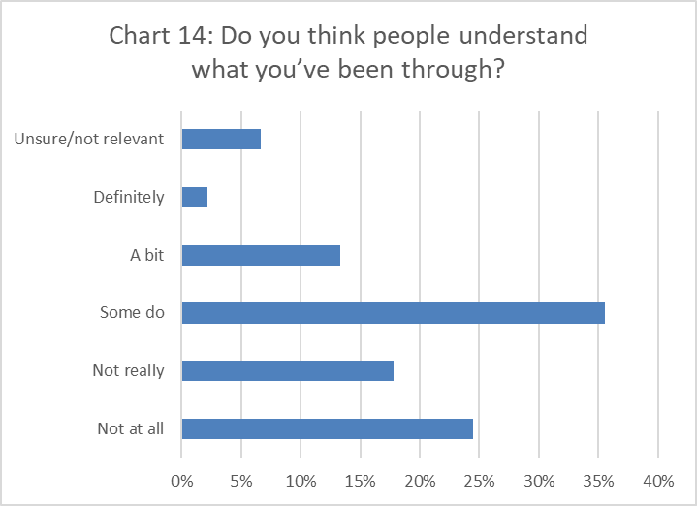

51% of participants who responded to this question chose to disclose additional information. A common theme which arose from these responses was a sense that non-disabled people do not understand what it’s like to be disabled, one participant described this as being “tired of trying to explain my experiences to people who've never had to deal with disability or long-term illness.” This is an issue preceding the pandemic; however it has shaped participants experiences over this period. Some participants said that most people didn’t understand how serious catching COVID could affect their health, or the precautions they were continuing to take to protect themselves. One participant said that most people “don't comprehend that catching Covid could result in severe consequences / death.” A few participants said it that seemed like many people simply didn’t care about how disabled people have been affected by the pandemic or the loosening of precaution. It is possible that the phrasing of the question confused some participants as the qualitative information presents a much clearer picture than the rating data.

87% of participants answered the question shown in Chart 14 below, of these 9% responded unsure/not relevant. 40% responded “some do”, followed by “a bit” (18%), “not really” (16%), and “not at all” (13%). For this question the data shows a fairly broad distribution of responses, suggesting a range of responses from different organisations.

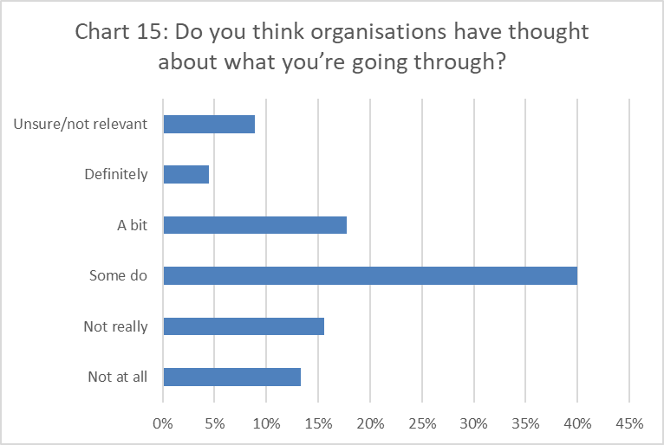

44% of participants who responded to the question chose to disclose additional information, many of the additional responses simply stated that there was a mixture of organisations who had thought about disabled people and organisations which hadn’t. One theme which came up here was an idea that some organisations had adapted well when non-disabled people were affected but dropped these adjustments as the focus moved towards ‘getting back to normal’. One participant described this as an “attitude that everyone is really happy to be back to in-person contact [when] … the hassle & cost for disabled people … can be prohibitive . Overall the detailed responses suggest a good deal of disparity between different organisations.

87% of participants answered the question shown in Chart 16 below, of these 2% responded unsure/not relevant. 69% responded “not at all”, followed by 13% who responded, “not really”. The responses to this question show that participants overwhelmingly felt that the government hadn’t thought about what they were going through during the pandemic.

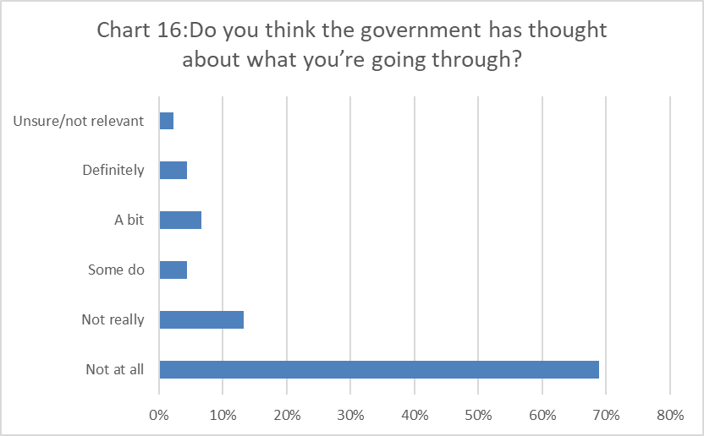

53% of participants who responded to this question chose to disclose additional information. The main theme which came through from these responses was a sense that the government simply didn’t care about the impact of their policies on disabled people. One example was someone who stated that the government “make conscious choices to make our lives harder … they don't care but it's calculated rather than callous cruelty.” Several participants said that the government had left decisions around masking and over COVID precautions to individuals and organisations and left many disabled people in a vulnerable position as a result of this choice. One participant felt that the government “abandoned all practical safety measures and left it to individual responsibility.” Notably there was far more anger in these responses than we saw elsewhere in this research, there was a sense of betrayal in the responses to this question. One participant felt that “the government has only shown themselves to be more ableist than even the most cynical among us thought they were.”

6.8) Other Comments

58% of participants answered the question “is there anything else you’d like to tell us?” The responses covered a broad range of perspectives and topics, however no single topic arose often enough to be identified as an analytically significant theme which was worth sharing here. Many participants reiterated themes which have been identified in the responses to other questions, others identified specific personal issues which didn’t offer meaningful insights into issues relating to disabled people more generally. We view this as a positive sign as it suggests that there was not a significant gap in our question set or an issue that we should have included which we overlooked when planning the research.

77% of participants answered the question ‘overall, how have you felt during the pandemic?” This was a very open question and as such it gathered a wide range of responses, within these we identified four themes which came up over and over again. The most common response was isolated or lonely, with almost every participant who responded to this question mentioning some version of this. Sad or depressed were the next most common descriptors. These were followed closely by scared or anxious, which were also frequently used terms. Less common but still used enough to be significant were descriptions of being tired or burnt out. Overall the thematic analysis of the responses to this question paints a worrying picture of participants mental health over the past 2 years.

1. Limitations

As mentioned in the demographics section, the lack of ethnic diversity in our dataset is the main weakness of this research. With 87% of participants being white we cannot be sure that the insights derived from this report are consistent across other ethnic groups. It is worth noting that we did not explicitly target any ethnic groups in our initial outreach and promotional work. Why our approach to promotion failed to engage with a diverse range of ethnic communities is unclear at this time. This issue was identified during the data collection stage and targeted outreach was carried out to engage with some BME groups. However, this outreach ultimately failed to have enough of an impact to address this issue.

Another limitation of our approach was the data collection period. This was a relatively short research project, with data collected over a period of 3 months between July and September 2022. The pandemic has been through many different stages – lockdowns, restrictions, and measures to support people through the pandemic have been constantly evolving since March 2020. It is reasonable to think that if we had carried out this research in a different period during the pandemic or run data collection through a longer period, we may have yielded very different results. While we did invite participants to reflect on their experiences throughout the pandemic, it is inevitable that they will privilege their current perspective over how they were feeling a year or more ago. Unfortunately this limitation is unavoidable given the restraints of these insight reports.

This issue was particularly pronounced when asking about how people felt during the pandemic. Evidence based methods such as the Warwick-Edinburgh Mental Wellbeing Scale or ONS wellbeing questions are not designed or tested to work over such a long time period. As such we had to use a qualitative approach and accept the limitations of that data.

The methodology used for this research did not gather responses from non-disabled people. This means that we cannot draw direct comparisons between disabled and non-disabled responses which would allow us to measure differences between these perspectives and identify specific effects the pandemic has had on disabled people. For example, if we had collected data from a control group we could compare how disabled and non-disabled participants experiences around isolation. Without this we have to use other sources of information to extrapolate which experiences are specific to disabled people. This was a practical limitation as collecting this control data would have diverted time and resources away from outreach to our target population.

1. Recommendations

Based on the findings of this research we identified four key areas where interventions and support could have a significant impact on disabled people. These extend beyond the remit or reach of our project. The intention is that further work could be undertaken to develop these ideas and validate our findings.

**Working from home** has been beneficial for many of the participants in this research. Removing travel, allowing for appropriate precautions, and granting greater freedom to adapt working environment has done a great deal to improve the accessibility of work. It’s worth noting that this is not a solution for everyone, as this research has shown there is no one-size-fits-all approach to accessibility. There remain significant challenges to be addressed, including adapting management and putting strategies in place to protect workers from isolation. Our view is that despite these challenges, the adaptations put in place by many workplaces gave an unprecedented opportunity to experiment with ways of working. From this we can learn what works and what doesn’t work and use that to inform more inclusive and accessible ways of working moving forward. **We recommend that commissioned services lead by example, offering flexible ways of working and developing good practice which other employers can learn from.**

**Healthcare** has suffered over the pandemic, coming on the back of existing issues within the NHS. While this affects everyone, disabled people are more likely to need regular healthcare check-ups and specialist treatment and as such are more heavily affected by this issue. In this research we have seen that moving towards online and phone appointments have helped some but excluded others who have struggled to adapt to these approaches. **Moving forward a hybrid approach offering online, phone, and in person support could give patients better support by improving the accessibility of healthcare.** We also note with concern that increased waiting times and difficulty securing appointments creates a substantial barrier to accessing healthcare. Disengagement with the health system, or delays in accessing treatment can have serious long-term effects on patient’s health. This is especially likely for people living with complex health conditions which can deteriorate if not well managed.

**Isolation** has been a significant issue for everyone during the pandemic. Being restricted in how we are allowed to socialise with and having to adapt to online socialisation alongside all the other impacts of the pandemic had a real impact on most peoples mental health. What concerns us is the potential for some disabled people to be left behind as the rest of the world moves back towards a ‘business as usual’ approach. Many participants have raised these concerns in their responses, feeling that they are being excluded as spaces and events they accessed online either end or move back to running in person. As with working arrangements, we developed new ways of socialising during the pandemic. We have an opportunity to use these tools and knowledge developed during the pandemic to build more accessible ways to socialise and reduce isolation and loneliness for many disabled people. **Integrating online social spaces and activities into service delivery could play a valuable role in supporting disabled people’s mental health.**

An issue which came up repeatedly during this research is a feeling that **disabled people are treated as an afterthought**. We saw this most prominently in the feedback around the accessibility of public spaces and in responses to the public understanding set of questions. Our research suggests that accessibility, and the impact of decisions on disabled people, have not been adequately thought about or supported during the pandemic. While we cannot amend the mistakes of the past, we can use this data to identify work which still needs to be done around this issue. Treating disability and accessibility as an inconvenience or an afterthought is a long term problem in decision making at every level. This is a key area where there remains important learning to be done to improve our inclusivity. **For commissioners and service providers this could include a review of service accessibility and an explicit focus on disability when evaluating service provision.**

1. Conclusion

Despite the limitations of the research, most notably our failure to effectively engage with BME communities, this insight report has gathered valuable insights into how disabled people in Leeds have been affected by the pandemic. From this we have created insights to help others better understand the impact the pandemic has had on disabled people and identified ways we can benefit from this learning.

We have seen the specific issues disabled people have faced around work, healthcare, the accessibility, and social isolation. We have identified ways in which disabled people have been left behind or excluded from changes as we come out of COVID restrictions. Perhaps more importantly we have identified some unexpected opportunities, in particular around working arrangements and healthcare. There are lessons to learn from the pandemic and tools we can use to build better, more inclusive ways of supporting disabled people moving forward.

One of the most important lessons from this research is that there is no one-size-fits-all approach to accessibility. What works well for some people can actually make things less accessible for others. Based on this it seems clear that flexibility is a crucial part of inclusivity. Hybrid models and a person-centred approach are the best option to meet a wide range of access needs.

The picture painted by the feedback is worrying. It shows a community which has struggled more than most during the pandemic, in the context of existing issues around the way disabled people are treated in society. Clearly there are important changes which need to made in how we approach disability to build a more inclusive and flexible approach to work, access to services, and public spaces.

1. Further Reading

Berger, Z., Altiery De Jesus, V., Assoumou, S. A., & Greenhalgh, T. (2021). Long COVID and Health Inequities: The Role of Primary Care. *Milbank Quarterly*, *99*(2), 519–541.

Boldrini, P. et al. (2020). Living with a disability during the pandemic “instant paper from the field” on rehabilitation answers to the COVID-19 emergency. *European Journal of Physical and Rehabilitation Medicine*, *56*(3), 331–334.

Braun, V., & Clarke, V. (2006). Using Thematic Analysis in Psychology. *Qualitative Research in Psychology*, *3*(2), 77–101.

Clegg, R.. (2021) *Disabled people forgotten during Covid, BBC research reveals.* BBC. https://www.bbc.co.uk/news/uk-57652173.

Cook, B., & Kerrigan, S. (2022, September). *Make life more inclusive: understanding disabled people’s access to activities, products and services*.

Courtenay, K., & Perera, B. (2020). COVID-19 and people with intellectual disability: Impacts of a pandemic. *Irish Journal of Psychological Medicine*, *37*(3), 231–236.

Dixon, S., Smith, C., & Touchet, A. (2018). *The disability perception gap*

Goering, S. (2015). Rethinking disability: the social model of disability and chronic disease. In *Current Reviews in Musculoskeletal Medicine* (Vol. 8, Issue 2, pp. 134–138). Humana Press Inc.

Healthwatch Leeds. (2020). *How does it feel for me during Covid 19? Week Commencing 14th September*.

Healthwatch Leeds. (2021). *How does it feel for me during COVID-19? Week commencing 24th May 2021*.

Healthwatch Leeds. (2021). *How does it feel for me during COVID-19? Week Commencing 8th March 2021*.

Hogan, A. J. (2019). Social and medical models of disability and mental health: Evolution and renewal. *Annals of Internal Medicine*, *191*(1), E16–E18.

John, E., Thomas, G., & Touchet, A. (2019). *The Disability Price Tag 2019*.

Michelen, M. et al. (2021). Characterising long COVID: A living systematic review. *BMJ Global Health*, *6*(9), 1–12.

Newman, M. (2021). Chronic fatigue syndrome and long covid: Moving beyond the controversy. *The BMJ*, *373*, 1–4.

Office for National Statistics. (2020). *Coronavirus and the social impacts on disabled people in Great Britain: September 2020*.

Office for National Statistic. (2021). *Outcomes for disabled people in the UK: 2021.*

Office for National Statistic. (2021). *Management practices, homeworking and productivity during the coronavirus (COVID-19) pandemic.* https://www.ons.gov.uk/economy/economicoutputandproductivity/productivitymeasures/articles/managementpracticeshomeworkingandproductivityduringthecoronaviruscovid19pandemic/2021-05-17#the-determinants-of-good-management-in-the-pandemic

Office for National Statistic. (2022). *Is hybrid working here to stay?.* https://www.ons.gov.uk/employmentandlabourmarket/peopleinwork/employmentandemployeetypes/articles/ishybridworkingheretostay/2022-05-23

Schalk, S. (2017). Critical Disability Studies as Methodology. *Lateral*, *6*(1).

TUC. (2021). *Disabled workers’ experiences during the pandemic*.

United Nations. (2020). *Policy brief: a disability-inclusive response to COVID-19.*

1. Appendices

11.1) Appendix 1: Questionnaire

11.2) Appendix 2: Flyer

11.3) Appendix 3: Outreach Log

This is a record to keep track of different groups and organisations who we’ve made contact with to promote the survey through Email, Social Media (SM), and face to face interactions (F2F).

|  |  |  |
| --- | --- | --- |
| **Group/Organisation** | **Form of Contact** | **Target** |
| Leeds Disabled People Organisation | Email | Service users/ Professional |
| Sikh Elders Service | Email | Service users |
| MHL Twitter/Instagram | SM | Direct |
| Touchstone Twitter | SM | Direct |
| Queers of Leeds FB Group | SM | Direct |
| SCOPE Community Engagement | SM & F2F | Direct/ Professional |
| Mens Health Unlocked Network | Email & F2F | Service users/ Professional |
| Touchstone Employees | Email | Direct/ Service users/ Professionals |
| AgeUK Leeds | Email | Service Users |
| Leeds Mencap | Email | Service Users |
| Voluntary Action Leeds | Email | Service Users |
| BID - Leeds Hearing & Sight Loss Support Service | Email | Service Users |
| Advonet | Email | Service Users |
| Coffee Shops (Flamingos, 200) | Flyers | Direct |
| GPs (Shakespeare, The Light) | Flyers | Direct |
| Pharmacies (Boots Trinity, Lincoln Green Pharmacy, Superdrug Kirkgate) | Flyers | Direct |
| Leeds Central Library | Flyers | Direct |
| Compton Centre | Flyers | Direct |
| Forum Central | Email | Professionals |
| Healthwatch | Email | Professionals |
| Leeds Mind | Email | Professionals/ Service Users |
| LCC Equalities Team | Email | Professionals/ Service Users |
| LCC Disability Network | Email | Professionals/ Service Users |
| Leeds Involving People | Email | Professionals/ Service Users |
| BME Mens Group | F2F | Service Users |
| People Matters | Email | Professionals |
| Disability Hub | Email | Service Users |