TOUCHSTONE
JOB DESCRIPTION

LOCALITY PRIMARY CARE MENTAL HEALTH SUPPORT WORKER – LEEDS MENTAL WELLBEING SERVICE

Grade: Agenda for Change Band 4, starting at £25,147 pa/pro rata
Hours: 2 x 37 hours per week
Responsible to: LMWS Manager/ Deputy and Clinical Lead
Employing Body: Touchstone
Location: Leeds

Any job offer will be dependent on the outcome of enhanced DBS and reference checks.

Background

Touchstone is part of the new Leeds Mental Wellbeing Service (LMWS) for Leeds. This exciting new partnership will mobilise and deliver an integrated service to offer primary care based mental health support for people with mild to moderate common mental health problems. Together, our partnership will help thousands of people in Leeds to increase their resilience and live their best lives within their community. The service comprises:
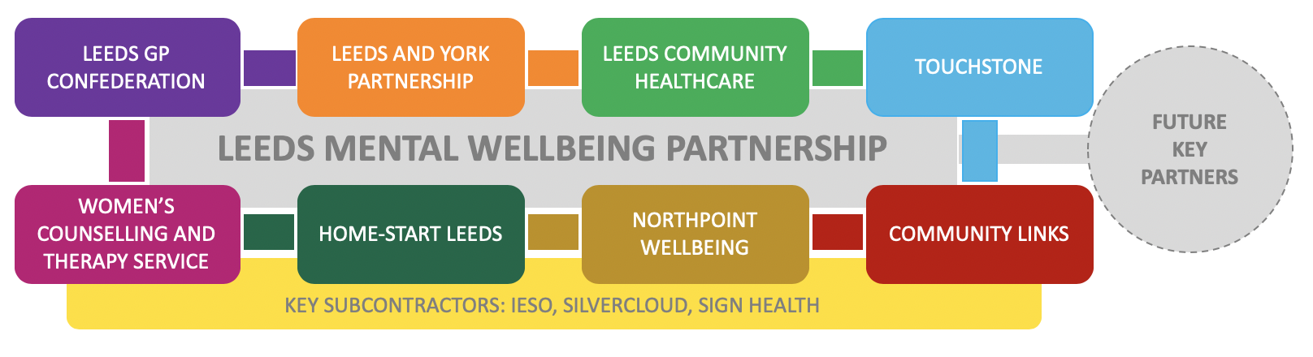

PURPOSE OF THE JOB

To work within Leeds’s locality based Local Care Partnerships, providing mental health support as an integral and critical part of a multi-agency and multi-disciplinary team.
You will increase the inclusivity of the LMWS, especially among communities most at risk of developing poor mental health and developing health and social inequalities, using a wide variety of engagement and delivery techniques.

ROLE DESCRIPTION

Inclusive engagement

- Understand mental health inequalities in Leeds and how some communities are at higher risk of poorer mental health than others.

- Deliver active in-reach into communities as prioritised by the annual health inequalities action plan for the LMWS, working alongside specialist organisations.

- To work as part of a team delivering open access and targeted drop-ins across Leeds, helping a broad range of people get access to the LMWS, with a focus on the most deprived communities.

- Having helpful conversations with prospective service users /patients, carers and referrers, so that they understand the offer and limits of the LMWS and are guided to the right support for them.

- Signpost and support people to the right intervention or service for them, internally or externally.

- To widen LMWS inclusivity through developing relationships with key stakeholders, networking and promoting the service.

Service delivery

- To use your knowledge of protected characteristics and the latest demographic intelligence to plan and facilitate interventions and activities alongside colleagues and service users.

- Support people to overcome barriers to accessing mental health interventions in the LMWS– this could mean accompanying people to appointments, ensuring that a buddy is in place, helping people with online resources etc

- Work alongside volunteers who deliver peer support interventions as part of the LMWS.

- To carry a caseload of service users and support them through brief one-to-one interventions, groups and/or enabling them to take part in or lead peer-led groups.

- Supporting a diverse range of colleagues (for example cognitive behavioural therapists or psychological wellbeing practitioners) to co-deliver clinical interventions together

- To co-design and deliver structured and non-structured group interventions which protect and improve mental health. These could be targeted at specific communities of interest, neighbourhoods or universal.

- To take a co-productive and inclusive approach to service user involvement, encouraging and supporting a diverse range of service users to get involved in the delivery and ongoing leadership of the service.

GENERAL

- To proactively feed information and intelligence into working groups and management structures, in order that the insight you gain as a front line deliverer of the service influences its future activities, service development and direction.

- To establish respectful, sensitive, professional relationships with people recognising the assets and strengths of individuals, maintaining professional boundaries and represent Touchstone in a knowledgeable and professional manner at all times, to positively manage risk and recovery to enable people to meet their full potential.

- To ensure that client records and other information systems are completed accurately and within agreed timescales and complete monitoring (including diversity monitoring) and evaluation of work undertaken in line with required timescales and to a high standard.

- To undertake out of hours work as required by the service.

- To be inducted, supervised, performance managed and appraised in line with the organisation’s performance management policies and procedures.

- To be responsible for personal learning and development where appropriate and undertake training, both mandatory and optional, to increase knowledge, skills and awareness.

- To be aware of and implement the general practices of Touchstone’s Health, Safety and Security policies and keep Managers informed about any serious and untoward incidents, safeguarding issues, health & safety concerns, financial issues, staff welfare.

- To operate within the aims, policies and practices of Touchstone at all times and to be committed to and promote the organisation’s equal opportunities and anti-discriminatory policies.

- To ensure information is dealt with in accordance with Touchstone’s policies around Confidentiality, Communications, Internet, Email and Telecommunications and steps are taken to ensure that confidential information is secure e.g. service user data.

- To undertake any other duties as directed by the Manager, in line with the responsibilities of this post.

June 2024

