

VOLUNTEER APPLICATION FORM

CONFIDENTIAL

If you require any help in filling in this form or wish to discuss any of the questions, please do not hesitate to ask. You can also refer to the ‘Advice on how to complete an application form’ document we have made to help you.

Title (Mr/Mrs/Ms/Miss/Mx):

Pronoun:

Name:

Surname:

Address:

Postcode:

Telephone/Mobile:

Date of Birth:

E-mail address:

Have a car (yes/no):

Please answer the following questions:

Why do you want to volunteer at Touchstone? You are welcome to share any details about yourself and your lived experiences you would like us to know.

Which of the following knowledge and skills do you possess?

 | Approachability |  |  | Assertiveness
 | Computer skills |  |  | Design skills
 | Emotional support |  |  | Flexibility whilst working
 | Good communication |  |  | Motivated and confident
 | Knowledge of mental health issues |  |  | Knowledge of Safeguarding
 | Listening skills |  |  | Numeracy
 | Personal responsibility |  |  | Organisation and prioritisation skills
 | Resilience |  |  | Respecting diversity
 | Sensitivity to the needs of others |  |  | Working as a team
 | Time management |  |  | Use of social media

Any others:

Which of the following relevant experience do you possess?

 | Administration |  |  | Advocacy
 | Befriending |  |  | Being a carer
 | Creating resources for a group |  |  | Delivering/supporting with training
 | Engaging with people from different backgrounds |  |  | Facilitating and/or attending community groups
 | Event planning |  |  | Leadership
 | Lived experience of mental health |  |  | Lived experience of support services
 | Support work |  |  | Presenting to groups
 | Peer mentoring |  |  | Speaking multiple languages
 | Running activities |  |  | Use of social media for outreach

Any others:

Do you have any hobbies and interests, or lived experiences you would like to share with us?

Is there anything else you want to share e.g. any support or access needs to be taken into consideration?

Which types of volunteer role/s are you interested in? For more information about our volunteer roles, please refer to our website.

 | 1-to-1 Work |  |  | Group Work
 | Administration |  |  | Advocacy
 | Befriending |  |  | Support in the community
 | Event Planning |  |  | Group Facilitation
 | Peer Mentoring |  |  | Running Activities
Is there a volunteer role/s you are specifically interested in?

Please state your availability for when you could volunteer.

Monday | Tuesday | Wednesday | Thursday | Friday | Saturday | Sunday
Mornings |  | Afternoons |  | Evenings |  | All Day

Are there any other availability considerations we should know about? (e.g. childcare, working patterns, health issues)

DISCLOSURE AND BARRING

Touchstone’s work involves working with vulnerable adults. Therefore, a check as to the existence and content of a criminal record will be requested from the Disclosure and Barring Service (DBS). This will be requested after a person has been accepted as a volunteer. Refusal to agree to a check being made could disqualify you from being considered for volunteering.

We have many volunteers and employees who have criminal convictions, and positively recruit people who do so. We consider each case on its own merits and work collaboratively to manage risk and ensure you are supported throughout the process.

You are therefore asked to sign the statement below to confirm you agree to a check being made on any criminal record you may have. Touchstone provides a social service function and is covered by the Rehabilitation of Offenders Act 1974 (Exception) Order 1975. Because of this we ask you to disclose convictions appropriate to the role in order to volunteer with us

Your data will be stored in accordance with GDPR regulations. We have put in place security measures to prevent your personal information from being accidentally lost, used, altered, disclosed or accessed in an unauthorised way. In addition, we limit access to your personal information to those employees who have a business need to know.

Please give details on the application form of all convictions, cautions, reprimands, or warnings below. If applying for admin volunteer role, please only disclose unspent convictions. For all other roles, both spent and unspent.

By signing the application form, I agree, if I am accepted to become a Touchstone Volunteer, to checks being made with the Disclosure and Barring Service for any record of convictions or cautions against me. I am aware that such information as appropriate for Enhanced Disclosures will be available.

REFERENCES

Please give the names and addresses of two people who would be willing to act as referees for you (please be aware family members cannot act as a reference for you):

First Reference:

- Name:
- Email address:
- Telephone:
- Relationship to you:

Second Reference:

- Name:
- Email address:
- Telephone:
- Relationship to you:

I declare that the information given in this form is correct and true, to the best of my knowledge.

Signed……………………………………. Date………………………………………

Please return completed application and equal opportunities form to the address below or send it via email to lmwspeersupport@touchstonesupport.org.uk

LMWS Volunteering
179-181 Haslewood Drive
Leeds
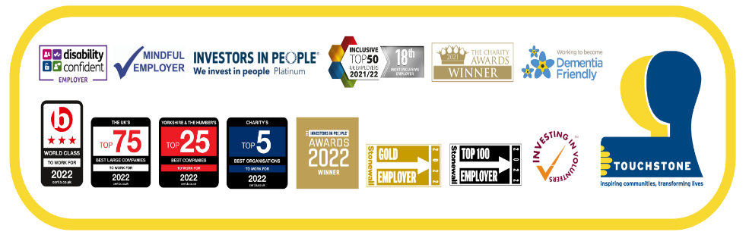
LS9 7RE

PRIVATE AND CONFIDENTIAL

Equal Opportunities Monitoring

We ask for this information because we try to ensure that our services are fair and equal to all. We monitor so that we can get a more accurate picture of the diverse people that we work with.

What is your preferred title?
Mr |  | Ms
Mrs |  | Mx
Miss |  | Other

Which of the following best describes your gender?
Woman |  | Man
Non-binary |  | I use another term (please state)
Prefer not to state

Are you trans?
Yes |  | No
Unsure |  | Prefer not to state

What is your sexual orientation?
Heterosexual |  | Bi
Gay or Lesbian |  | I use another term (please state)
Prefer not to state

Which age bracket do you fall into?
Under 18 |  | 55 – 64
18 – 24 |  | 65 – 74
25 – 34 |  | 75 – 84
35 – 44 |  | Over 85
45 – 54 |  | Prefer not to state

What is your religion/faith/belief?
 | Buddhist |  | Sikh
 | Christian |  | Other
 | Hindu |  | No religion
 | Jewish |  | No belief
 | Muslim |  | Prefer not to state

Do you consider yourself disabled?
Yes |  |  | No
Prefer not to state
If “Yes”, which disability/disabilities do you consider yourself to have?
Learning Disability |  |  |  |  | Physical Disability
Mental Health Disability |  |  |  |  | Sensory Disability
What is your ethnic background?
White British |  |  |  | Pakistani
White Irish |  |  |  | Chinese
White Welsh |  |  |  | Kashmiri
White Scottish |  |  |  | Other Asian background
White Northern Irish |  |  |  | White & Black Caribbean
White English |  |  |  | White & Black African
Other white background |  |  |  | White & Asian
Black African |  |  |  | Other mixed background
Black Caribbean |  |  |  | Arab
Other Black/ Caribbean/ African background |  |  |  | Gypsy / Irish Traveller
Bangladeshi |  |  |  | Another ethnic group
Indian |  |  |  | Prefer not to state

