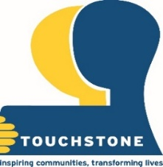
Touchstone (registered charity No. 1012053) is a leading voluntary sector agency providing high quality services to improve the health and wellbeing of local people
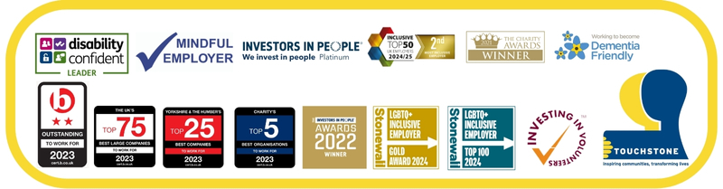
As an employee of Touchstone you will benefit from the following:
- Working for a diverse and inclusive organisation e.g. 36% *BME staff, 25% *LGBTQ+ staff, 16% *staff with a disability. Staff and peer support networks (*as above and many more)
- 28 days annual leave (rising to 31 after 2 years) + 8 bank holidays (pro-rata)
- Flexible working opportunities
- Personal wellbeing budget. Access to counselling and 24/7 confidential staff helpline.
- Health and wellbeing activities and fun staff team away days
- Inclusive maternity and parental policies and pay
- Additional day of leave as a celebration day or health and wellbeing
- Learning and personal development opportunities
Touchstone is an equal opportunities organisation, an equal rights employer and applications are welcome from all sections of the community, particularly, BME and LGB and Trans communities and/or people with disabilities who are under-represented within Touchstone. All applicants who disclose a disability and meet the essential criteria will be interviewed. Additional information can be obtained from our equal opportunities policy. Please note that we do not hold a sponsor licence and we do not intend to offer sponsorship for this particular role. You should therefore ensure that you have/will have the right to work in the UK to be able to undertake this role, if appointed, you will be required to provide relevant right to work documents at the point of an offer being made to you. Applications can be obtained by visiting www.touchstonesupport.org.uk or by e-mailing recruitment@touchstonesupport.org.uk. Please note that feedback is not provided to applicants who have not been shortlisted. We reserve the right to close this vacancy early if we receive sufficient applications for the role. Therefore, if you are interested, please submit your application as early as possible.

Touchstone is a multi-award-winning mental health and wellbeing charity operating in communities across Yorkshire. Touchstone understands that we can only deliver excellence to the people we serve if the people we recruit are happy, empowered, supported to reach their potential and trusted to lead.
The Leeds Mental Wellbeing Service is delivered in partnership with a number of consortium partner organisations including NHS partners and third sector organisations.
The post holder will be responsible for the effective leadership, management and operation of the Touchstone LMWS service. They will be accountable and responsible for delivering and influencing the delivery of a defined service. In doing so they will support the senior management team to deliver strategic targets and be responsible for the operational management of the service. They will lead on the management of Operational Team managers, by supporting, developing and ensure positive wellbeing of their teams and assess, plan, deliver and evaluate team performance and delivery of all roles within the Organisation.
They will support the Equality, Diversity and Inclusion Manager for ensuring that Health Inequalities are consistently addressed within the day to day practice of the service and they are fully engaged with developing co-production within the service and that the lived experience of peer support is integral to the service offered.
Information Session: Tuesday 13th January 4pm-4:30pm via Microsoft Teams
To attend, please email recruitment@touchstonesupport.org.uk
Closing Date: Sunday 18th January 2026
Interviews will be held on: Wednesday 28th January 2026 in Leeds

Contact details: Karen Fenton – Karenf@touchstonesupport.org.uk (07341469800)
Leeds Mental Wellbeing Service Partnership Manager
NHS Agenda for Change – Band 8a
30 hours per week

