Add a Referral to Touchstone CST
The following guide shows how to refer to this team.
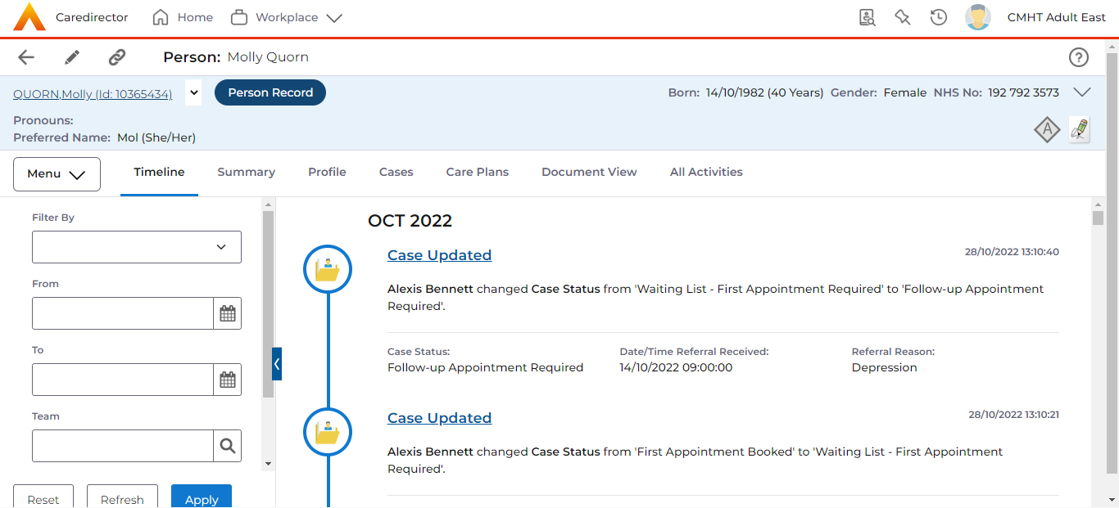
1. Start at the Person Record as shown below:
Note: We are in the PERSON record

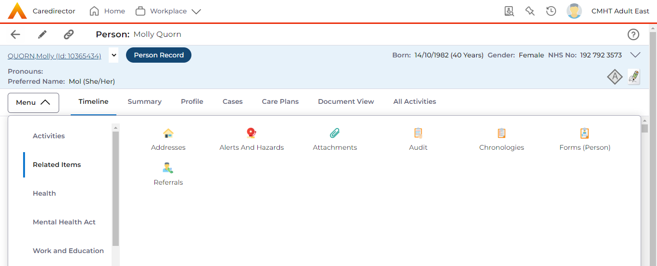
2. Click the Menu drop-down Related Items and click on the icon for Referrals as shown below:


3. Add a referral by selecting the + symbol:

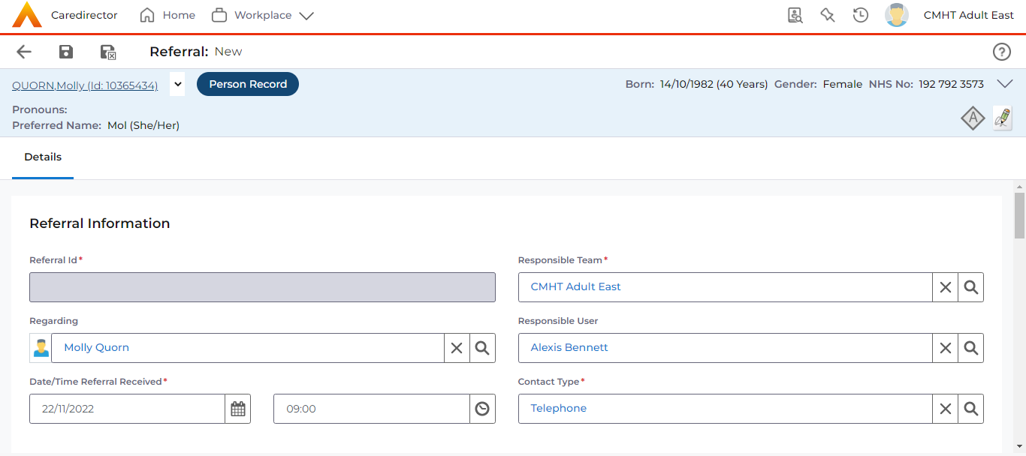
4. Complete as relevant to YOUR person. Following the above scenario, I entered the information as shown below:
Referral ID will populate after saving

5. Add referral source as ‘Internal Referral’ and ensure in the free text box that you write your name so the team can contact you if required
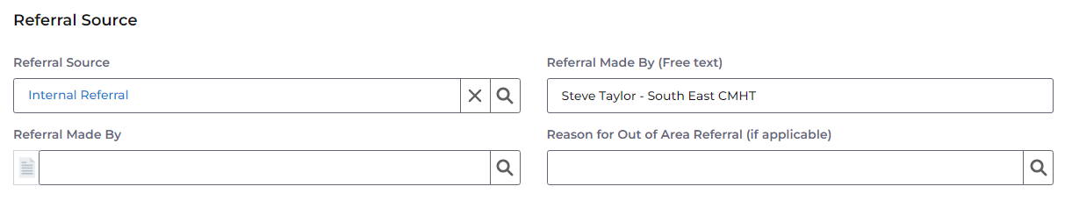
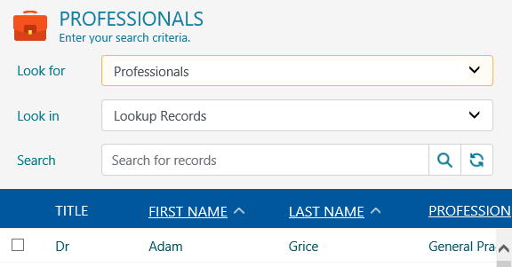
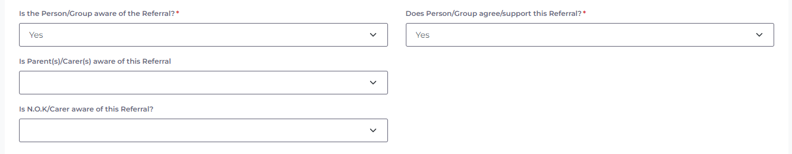
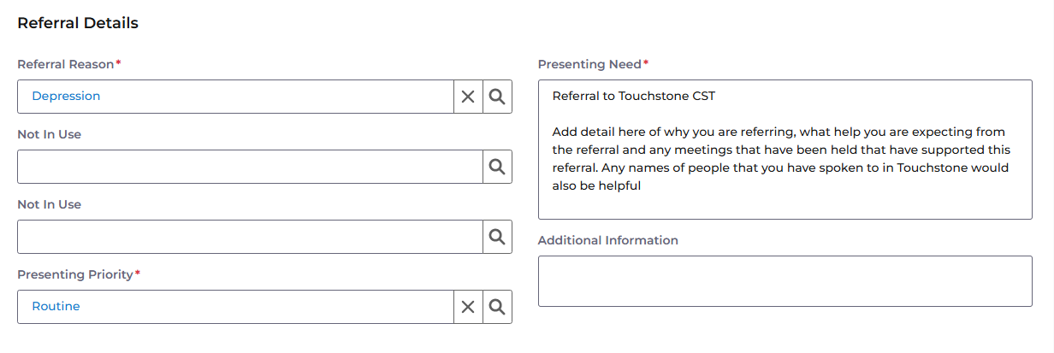
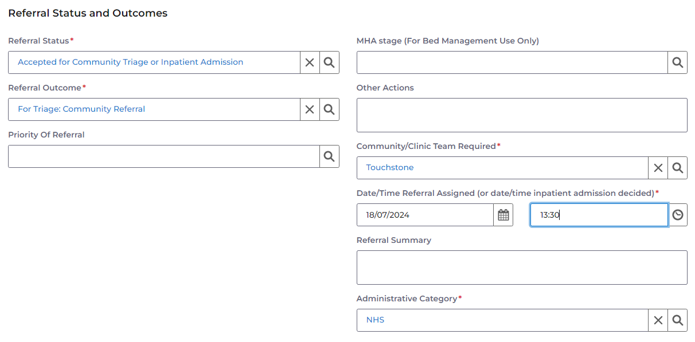
6. Add other relevant information, ensuring all areas with a red asterisk have been completed, below is about referral awareness.
7. Referral details should be added as below. Referral reason is related to diagnosis, presenting priority will usually be routine. Start the presenting need box with the line as below and then add any detail as needed/requested
8. This is the last section. Complete as below to ensure that the referral lands on the duty desk to be reviewed by the team. This team works within the Touchstone team on CareDirector


9. Once you’ve added all relevant information to the referral, click on the Save and Return icon in the top left corner and the process will be complete.

